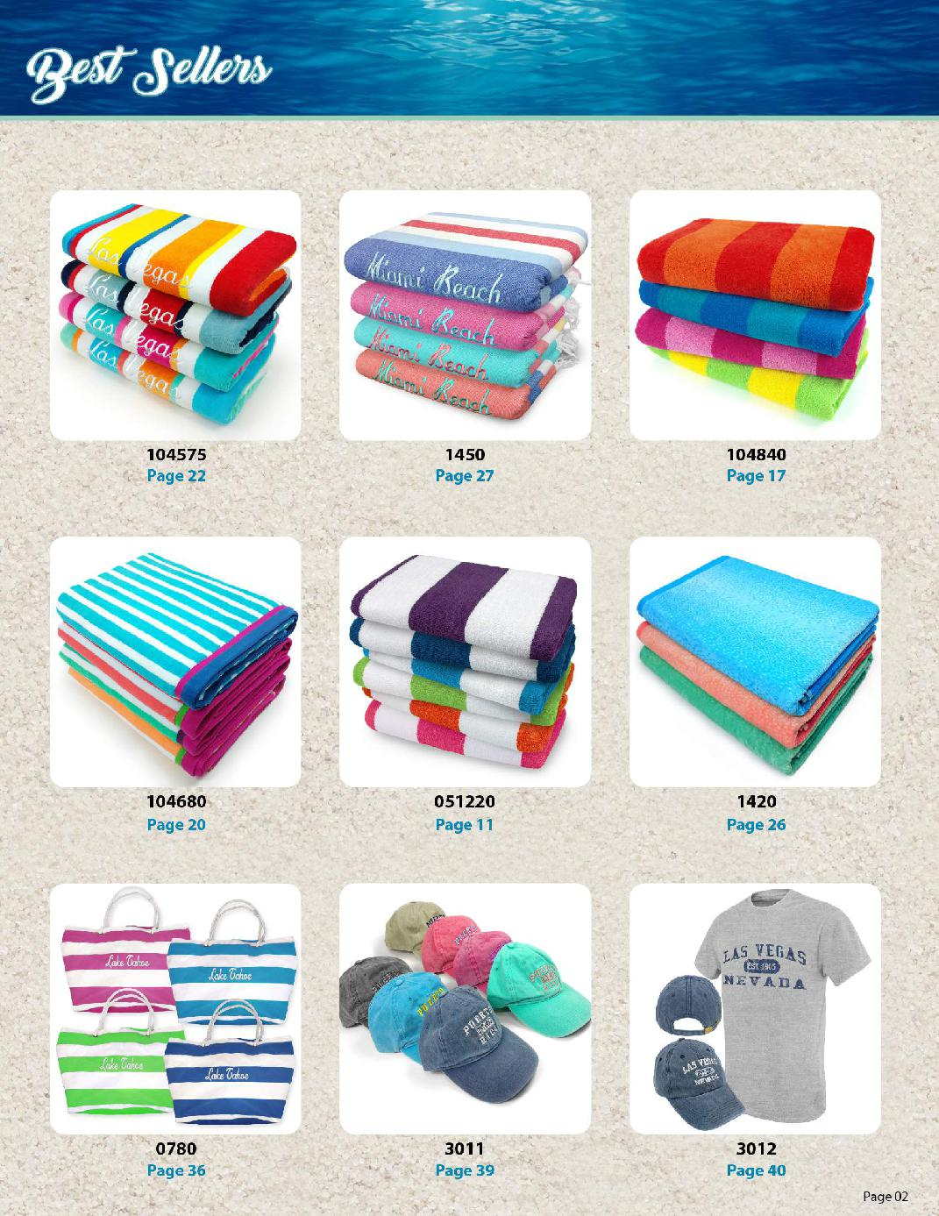
UNITED TEXTILE SUPPLY
303-257-6144 or 609-616-5009
UNITEDTEXTILESUPPLY.COM
NOTICE:
All Products can be ordered BLANK-NO Embellishment

UNITED TEXTILE SUPPLY

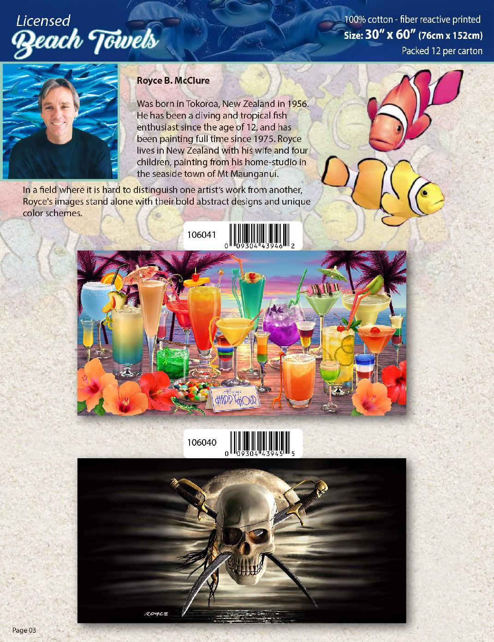

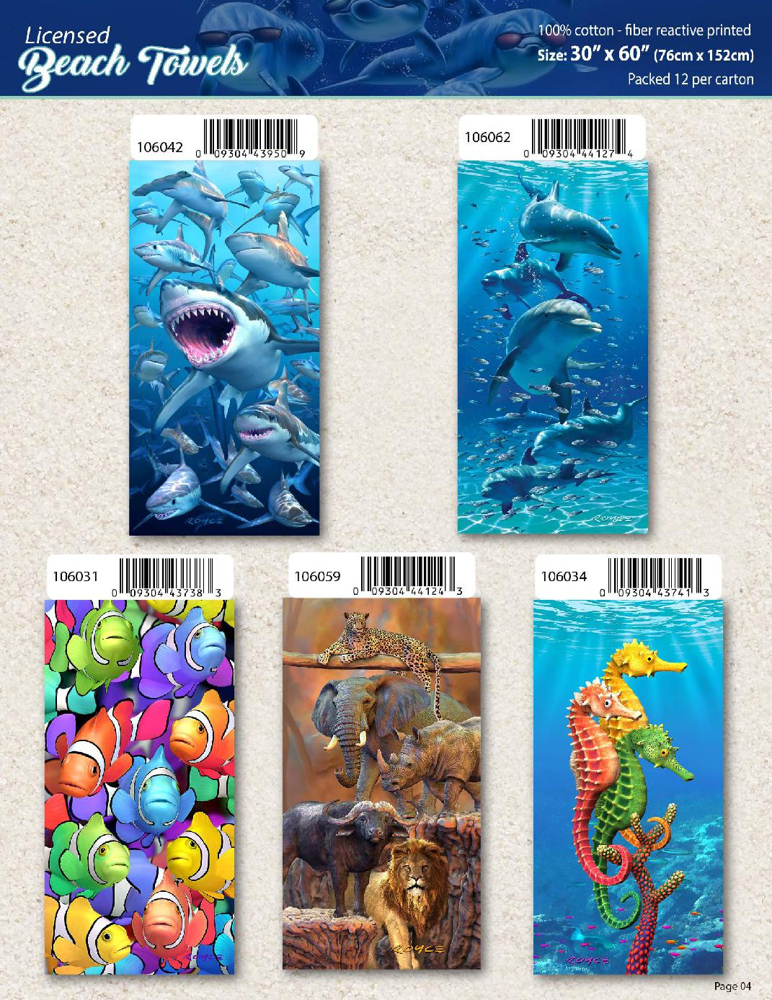

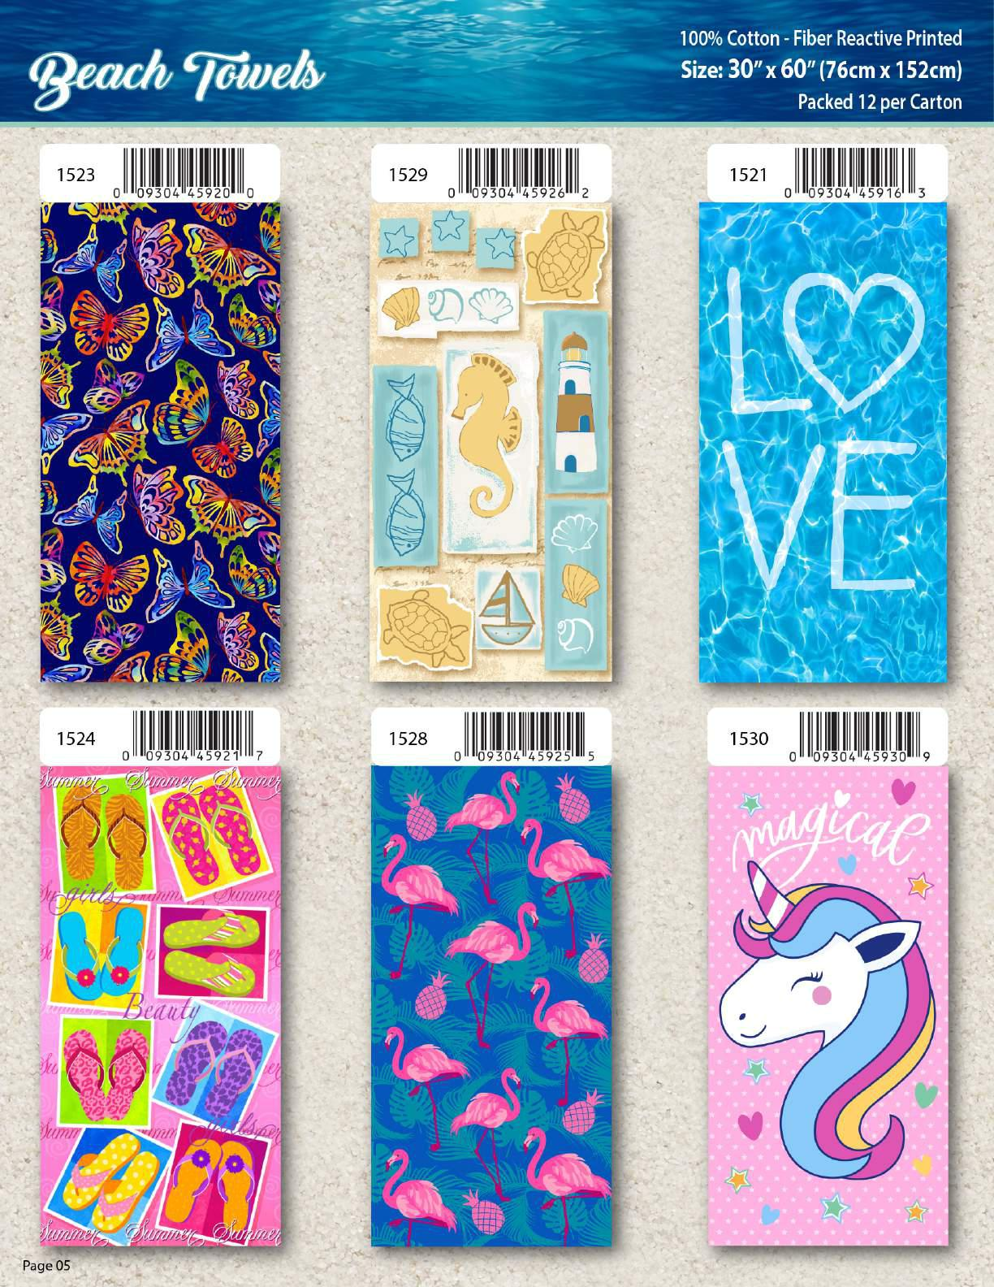

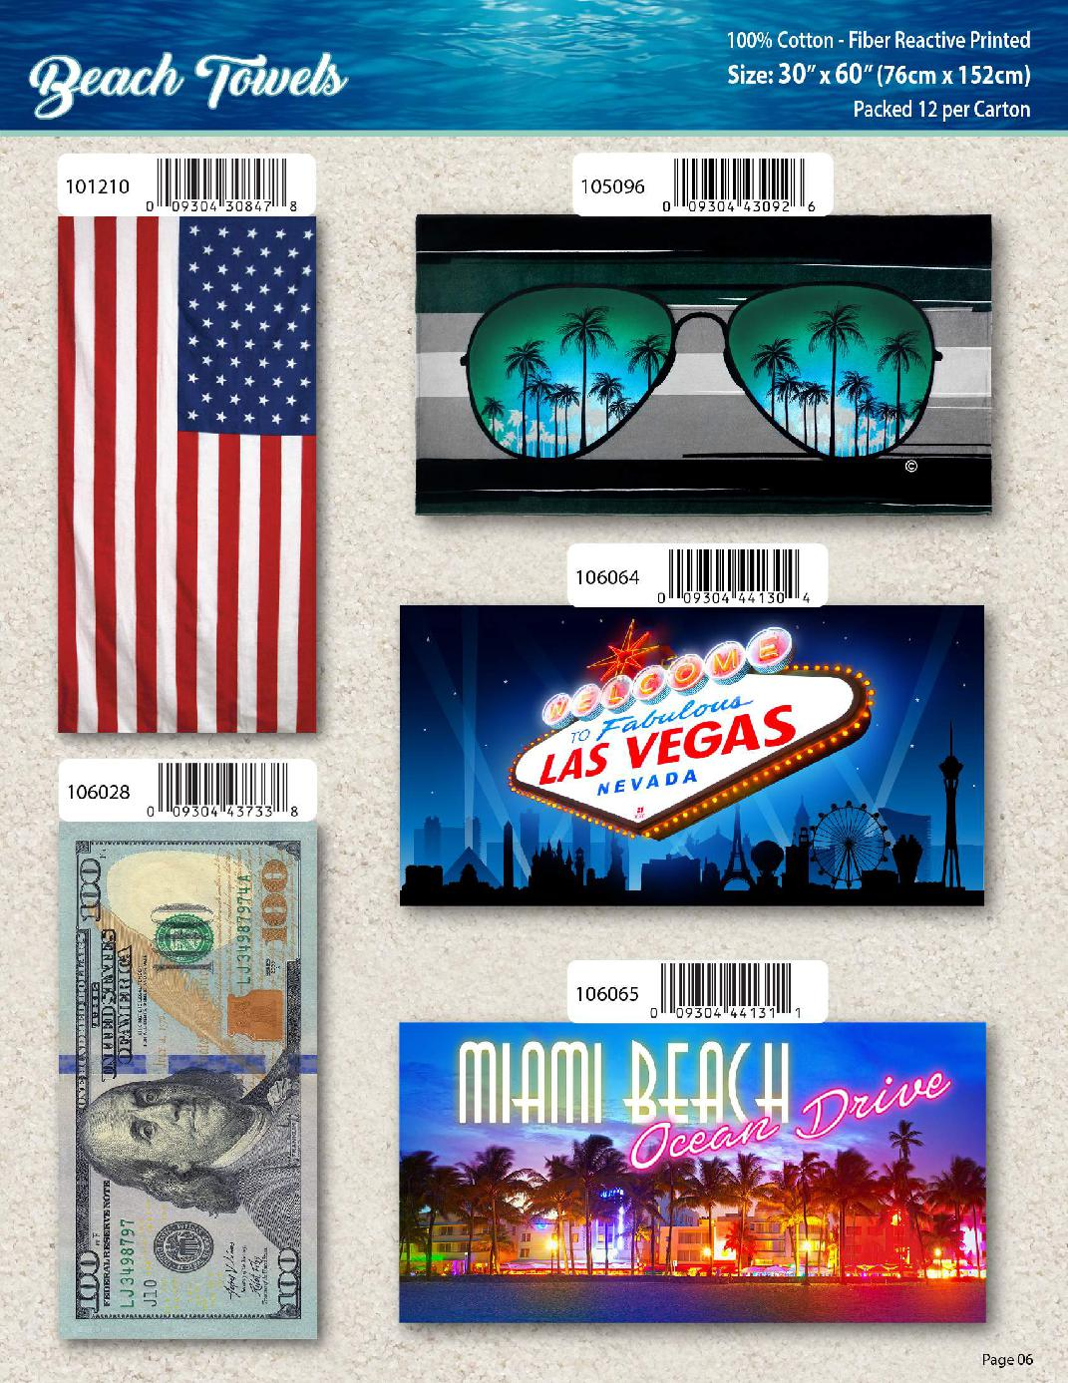

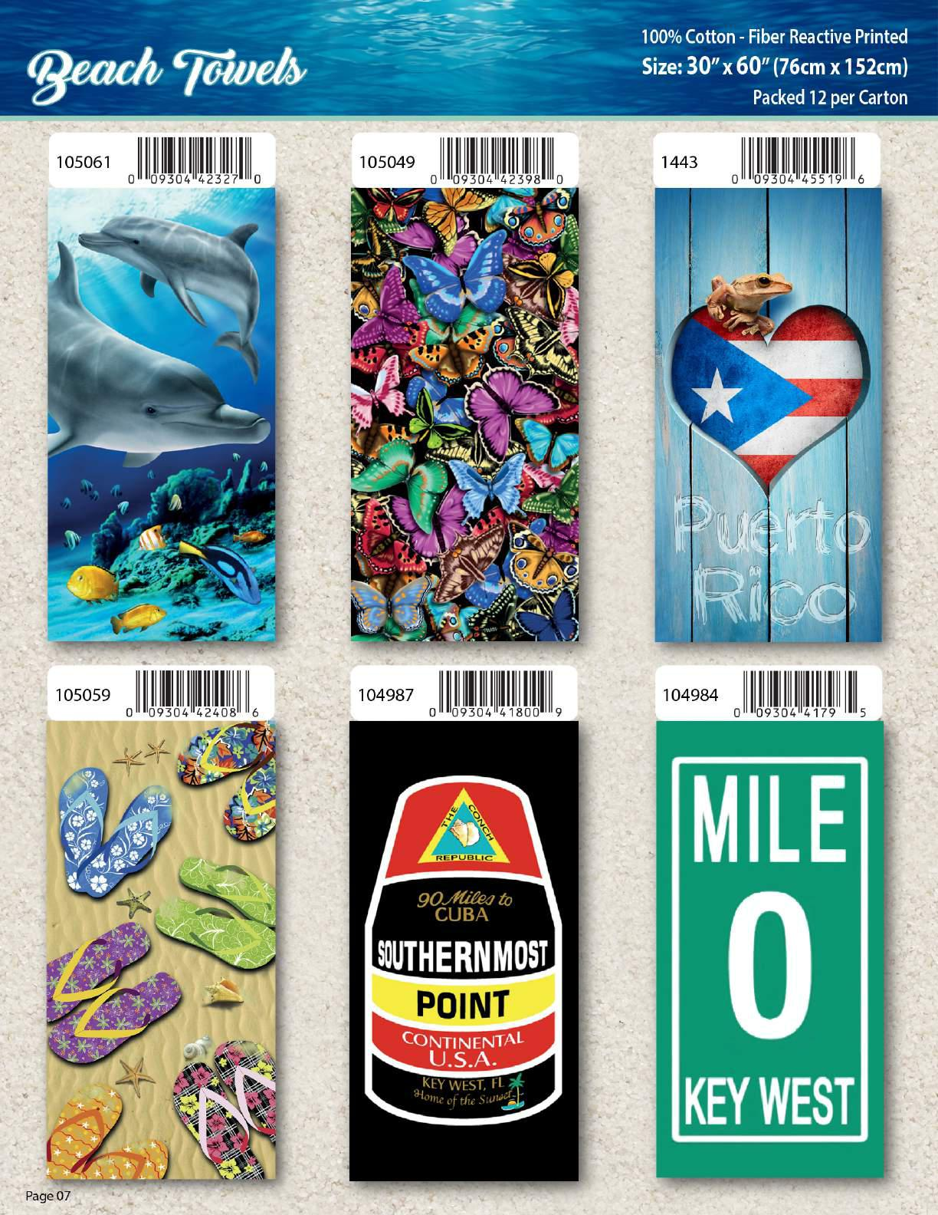

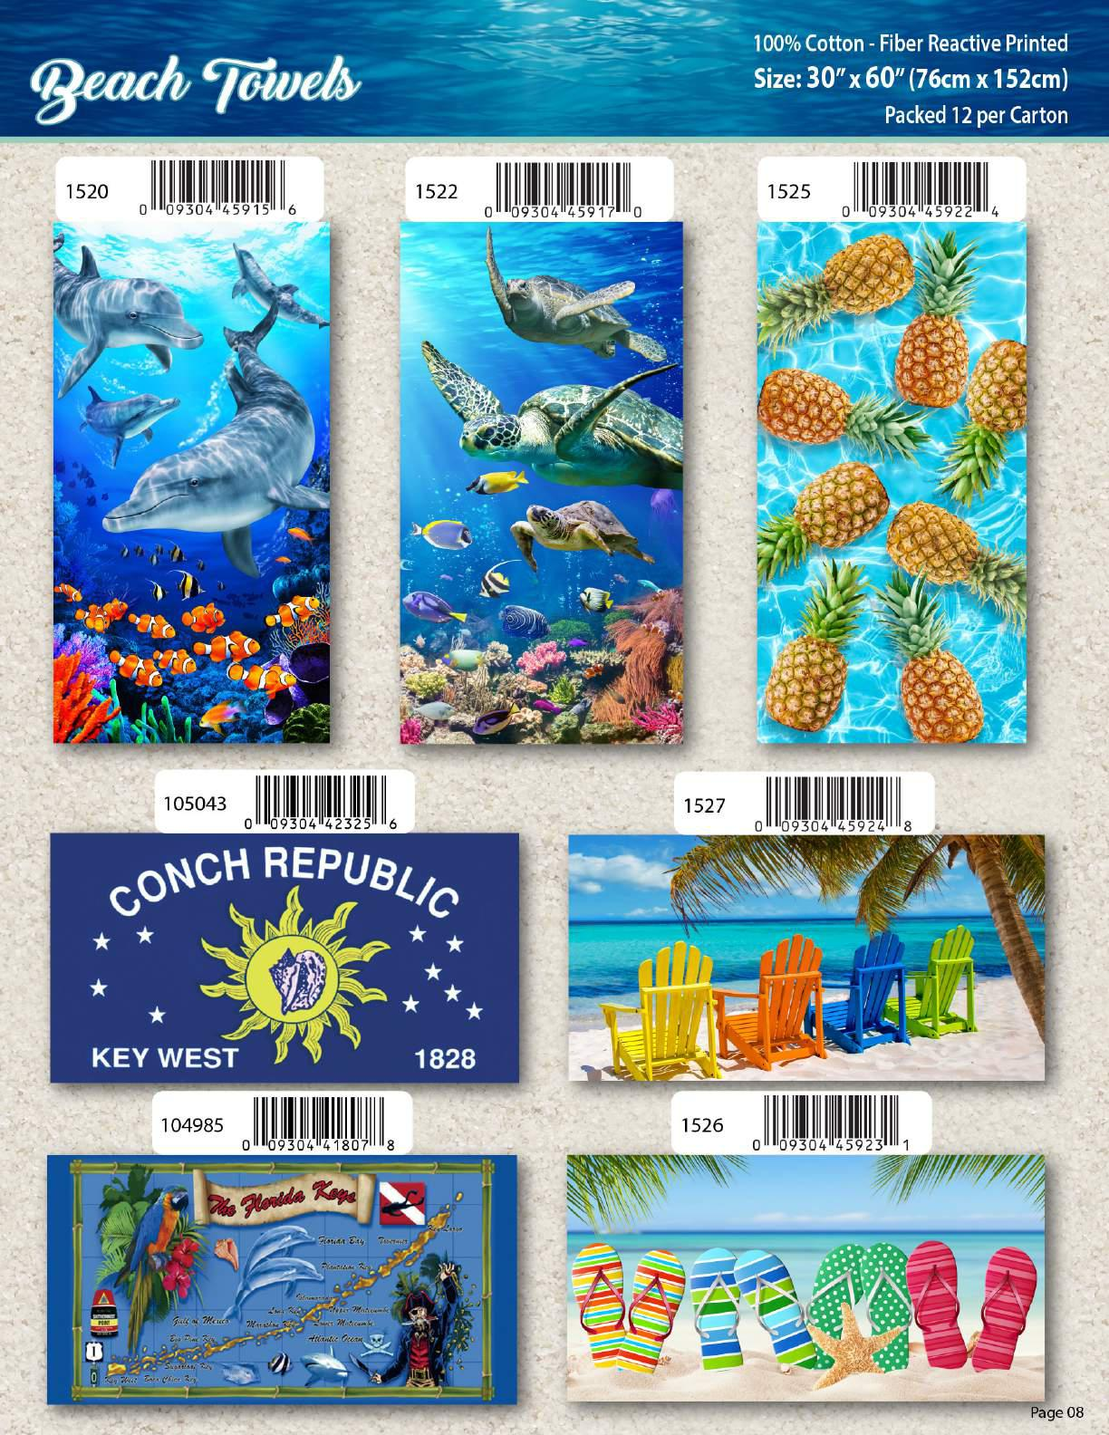

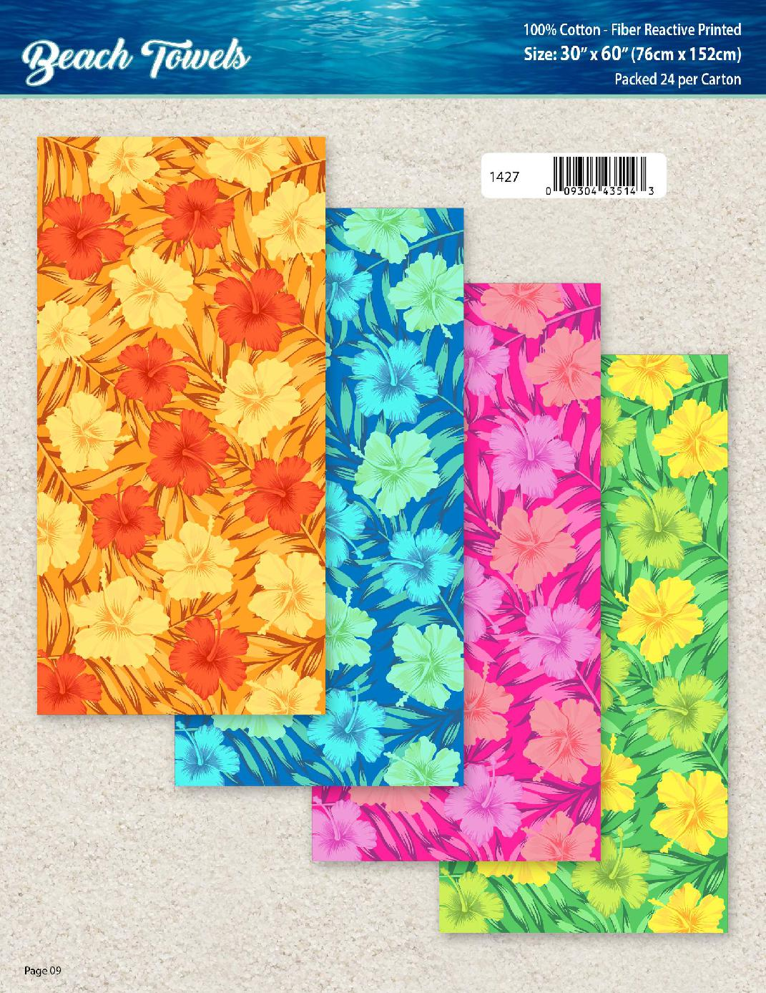

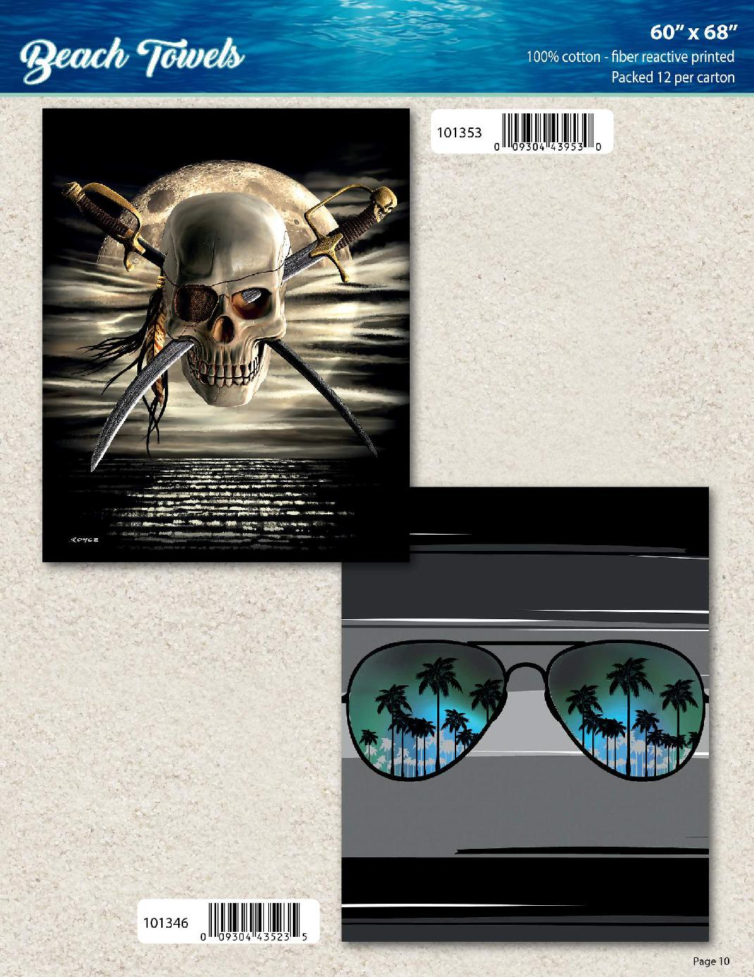

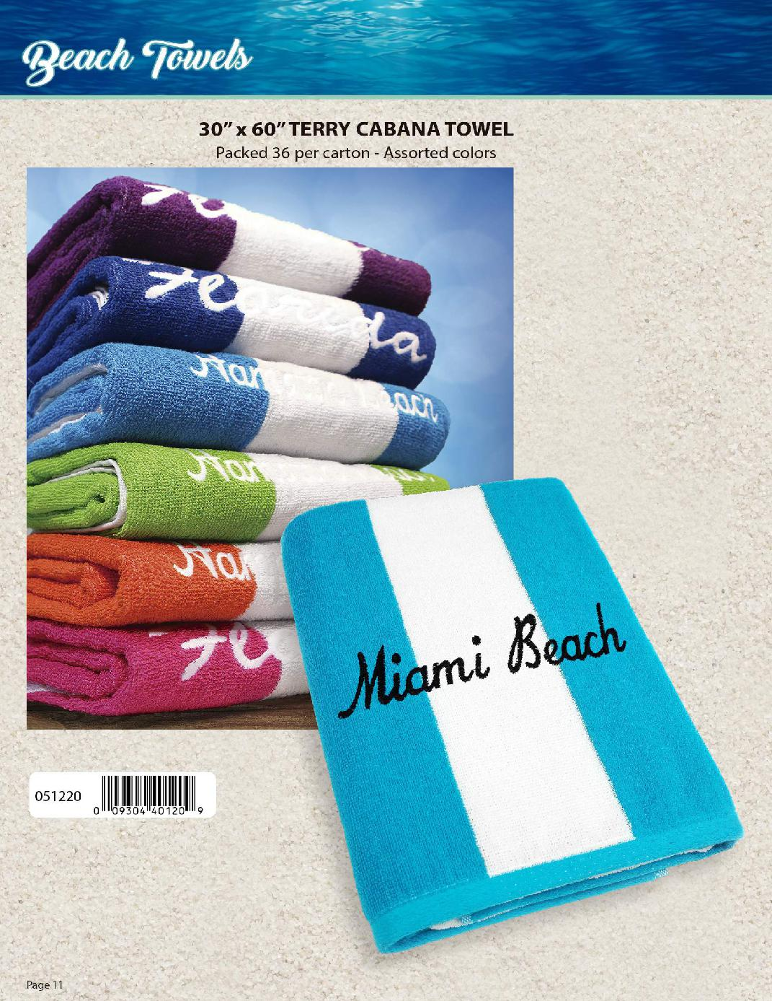
NOTICE:
All Products can be ordered BLANK-NO Embellishment
303-257-6144
609-616-5009

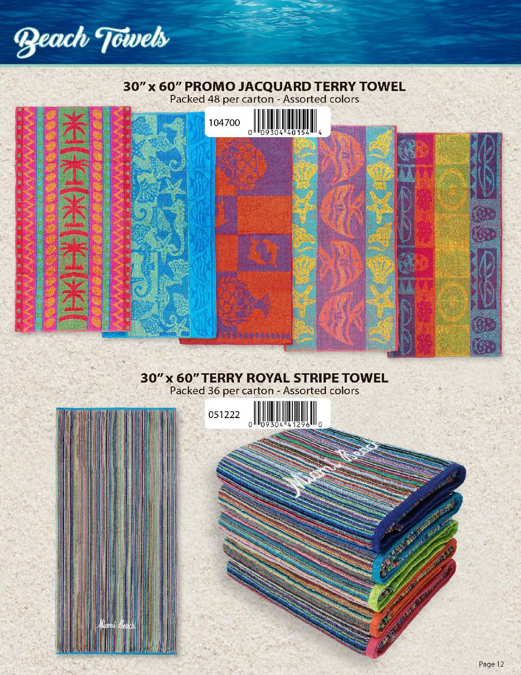

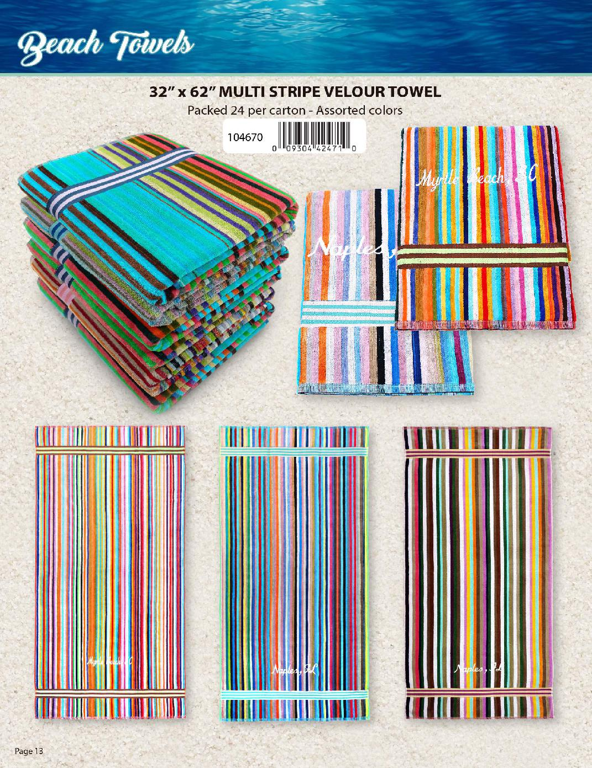
All Products can be ordered BLANK-NO Embellishment

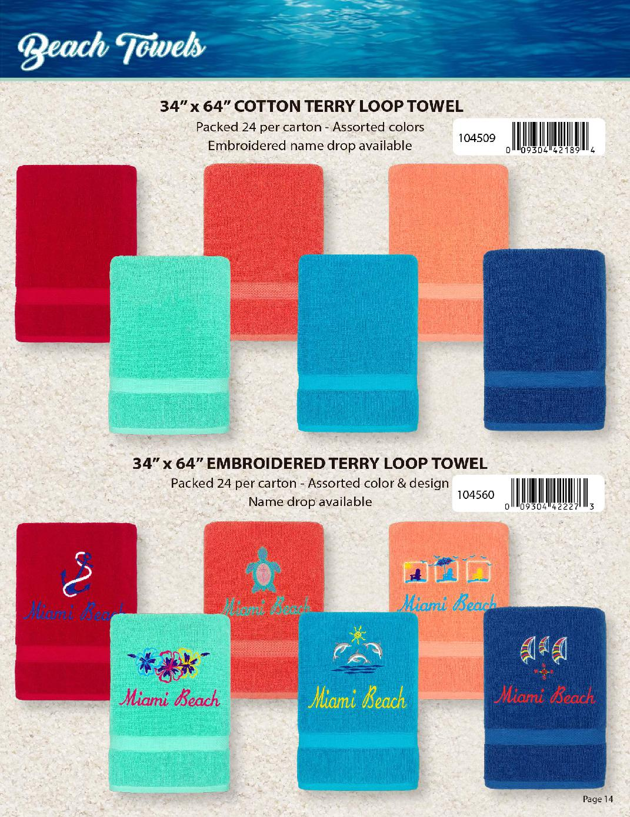
NOTICE:
All Products can be ordered BLANK-NO Embellishment
303-257-6144-Patrick
609-616-5009-Ron

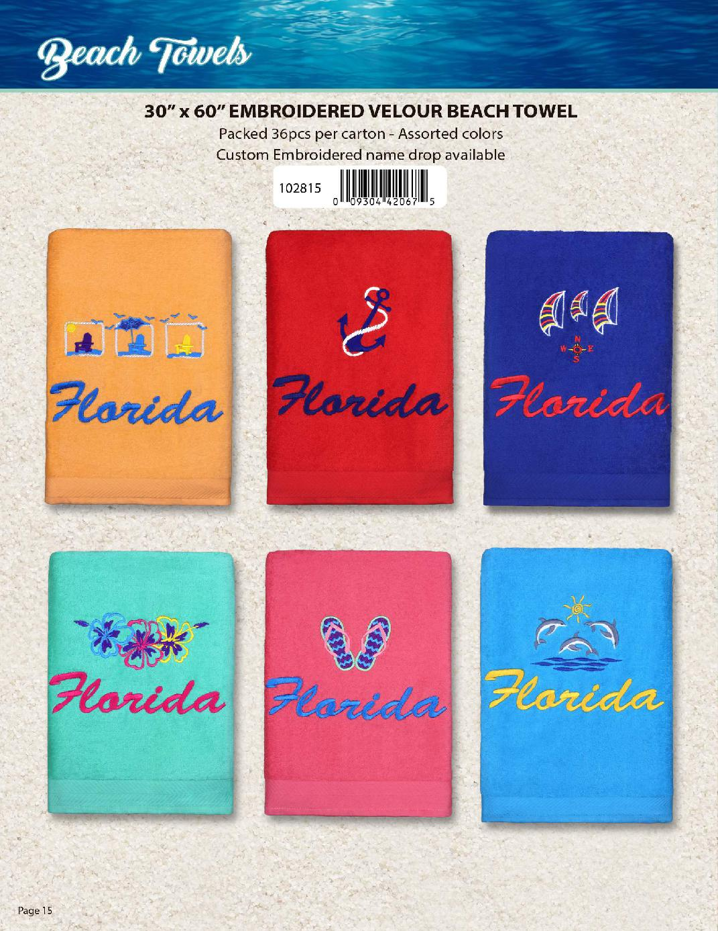
NOTICE:
All Products can be ordered BLANK-NO Embellishment
Ron-606-616-5009
-Patrick 303-257-6144

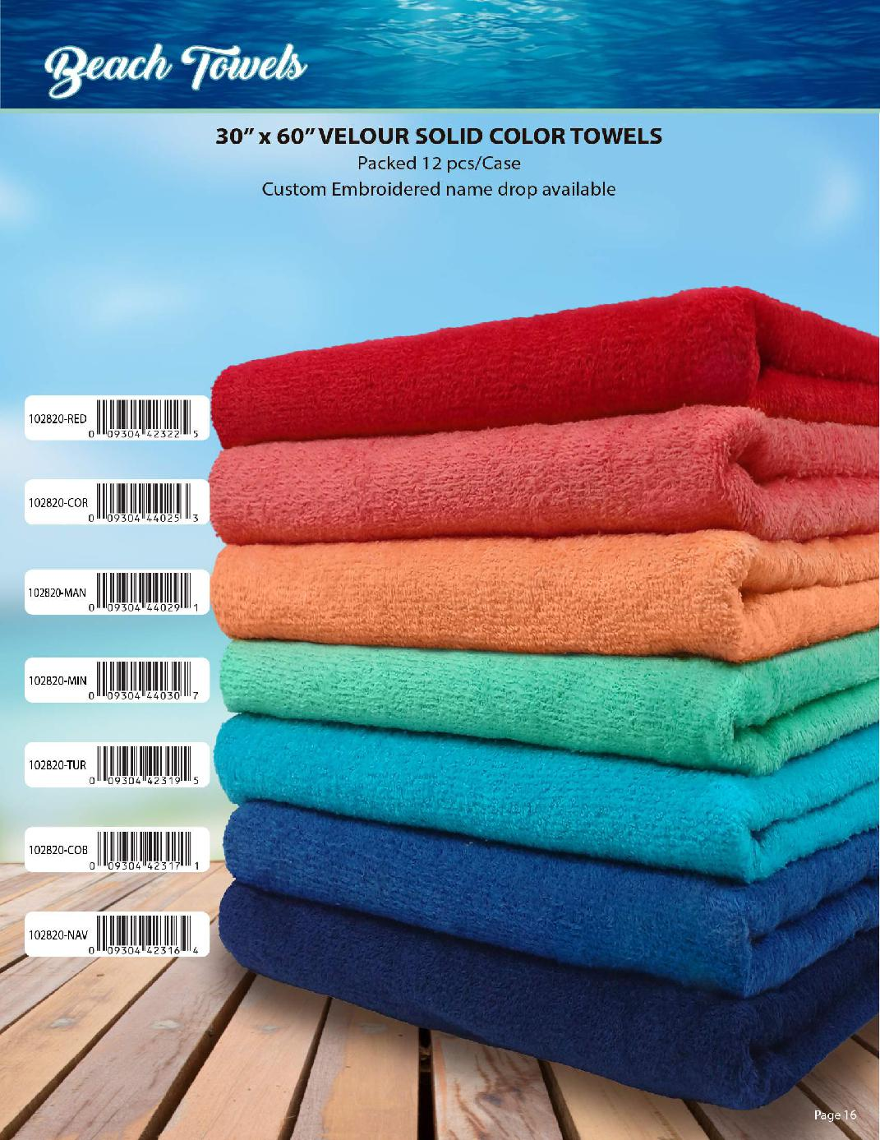

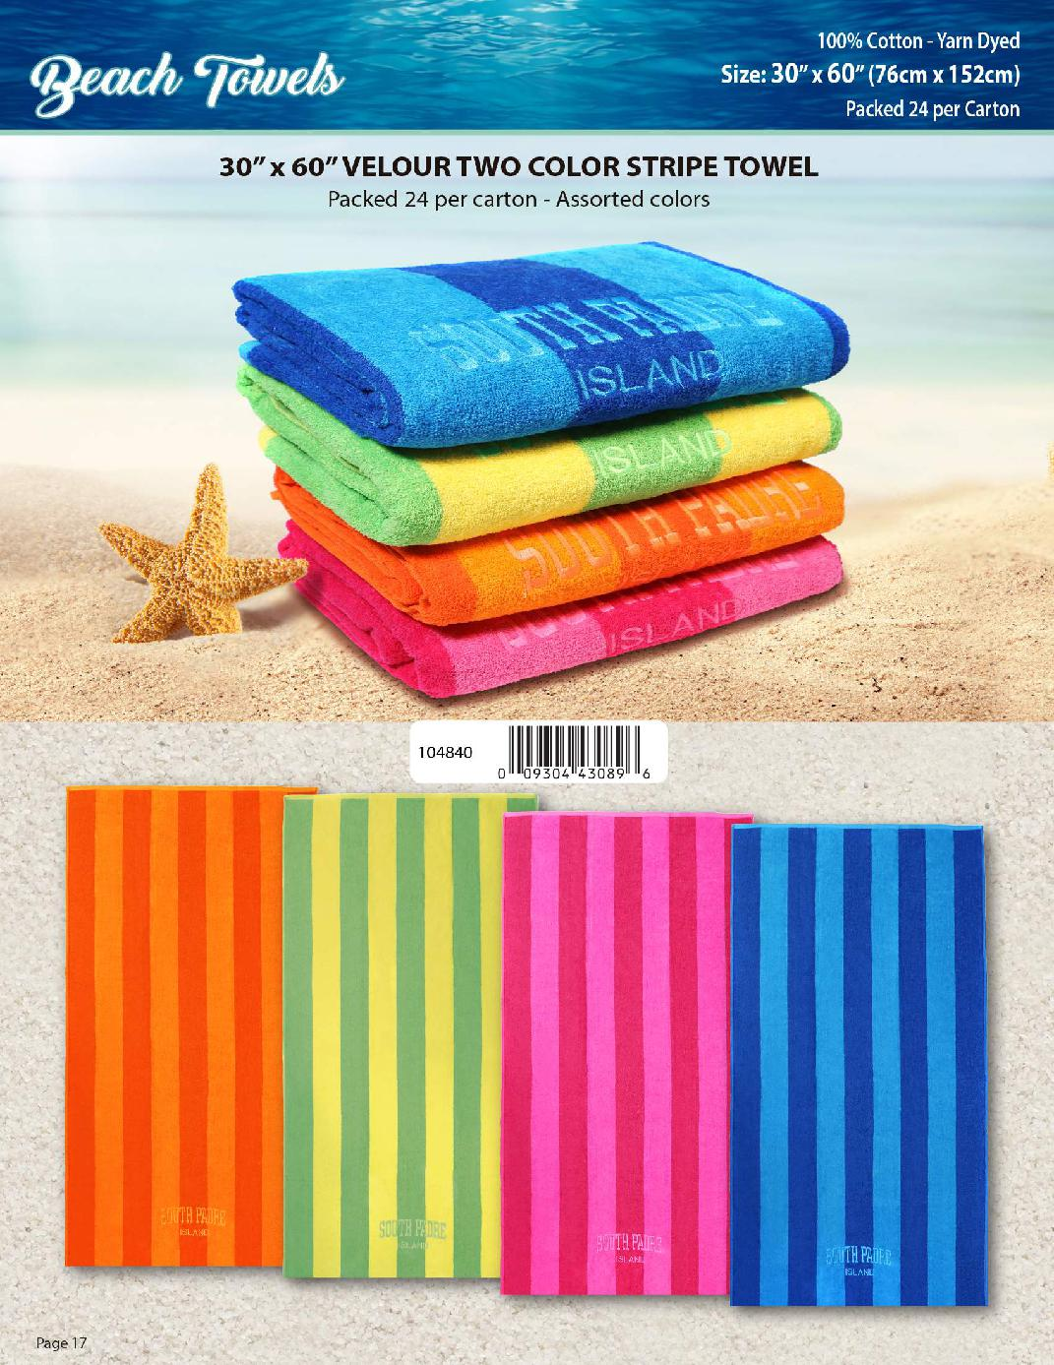

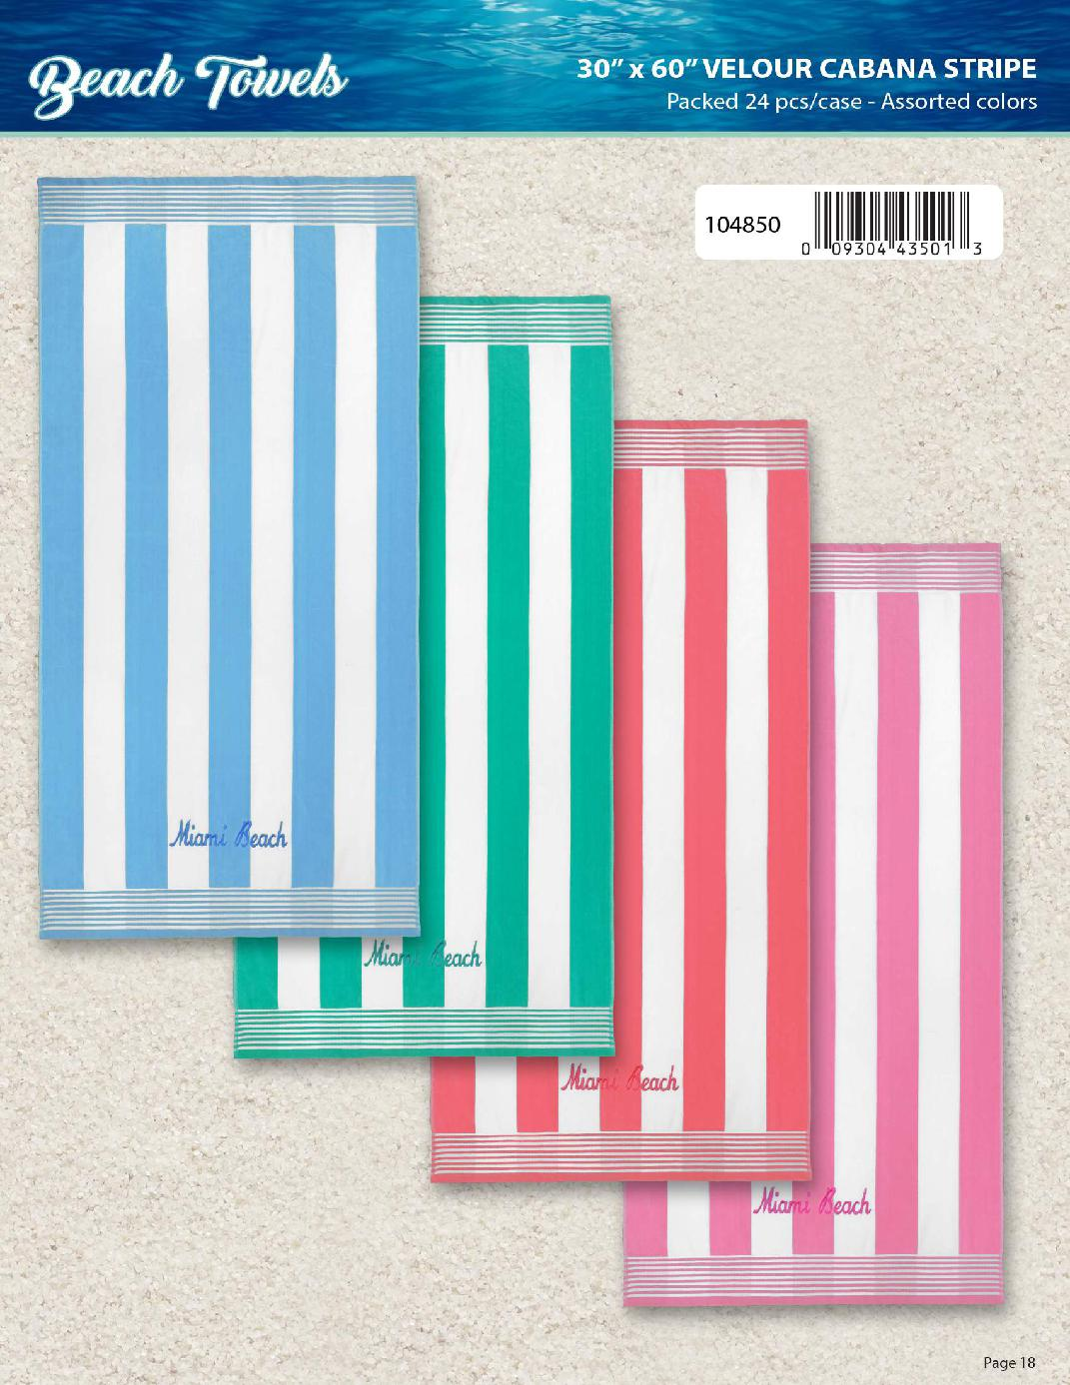
A
NOTICE- All products can be ordered BLANK-NO EMBELLISHMENT
Ron-609-616-5009
Patrick 303-257-6144

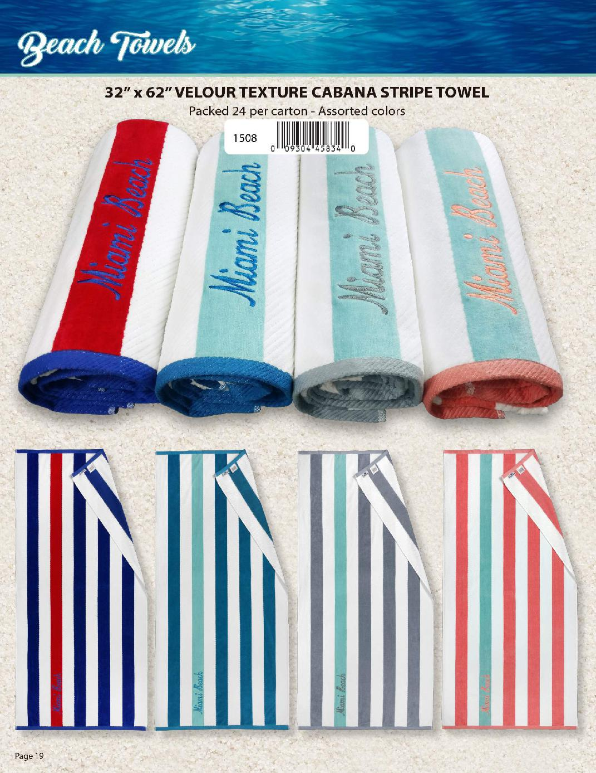

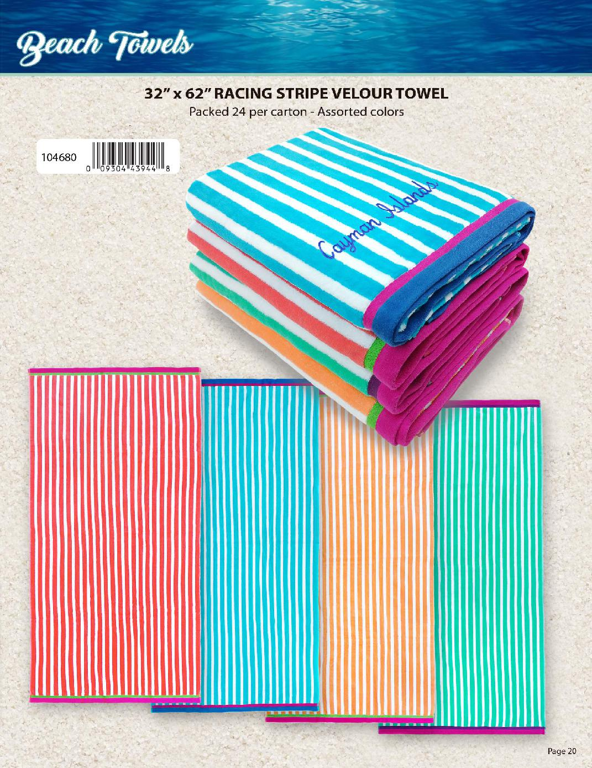

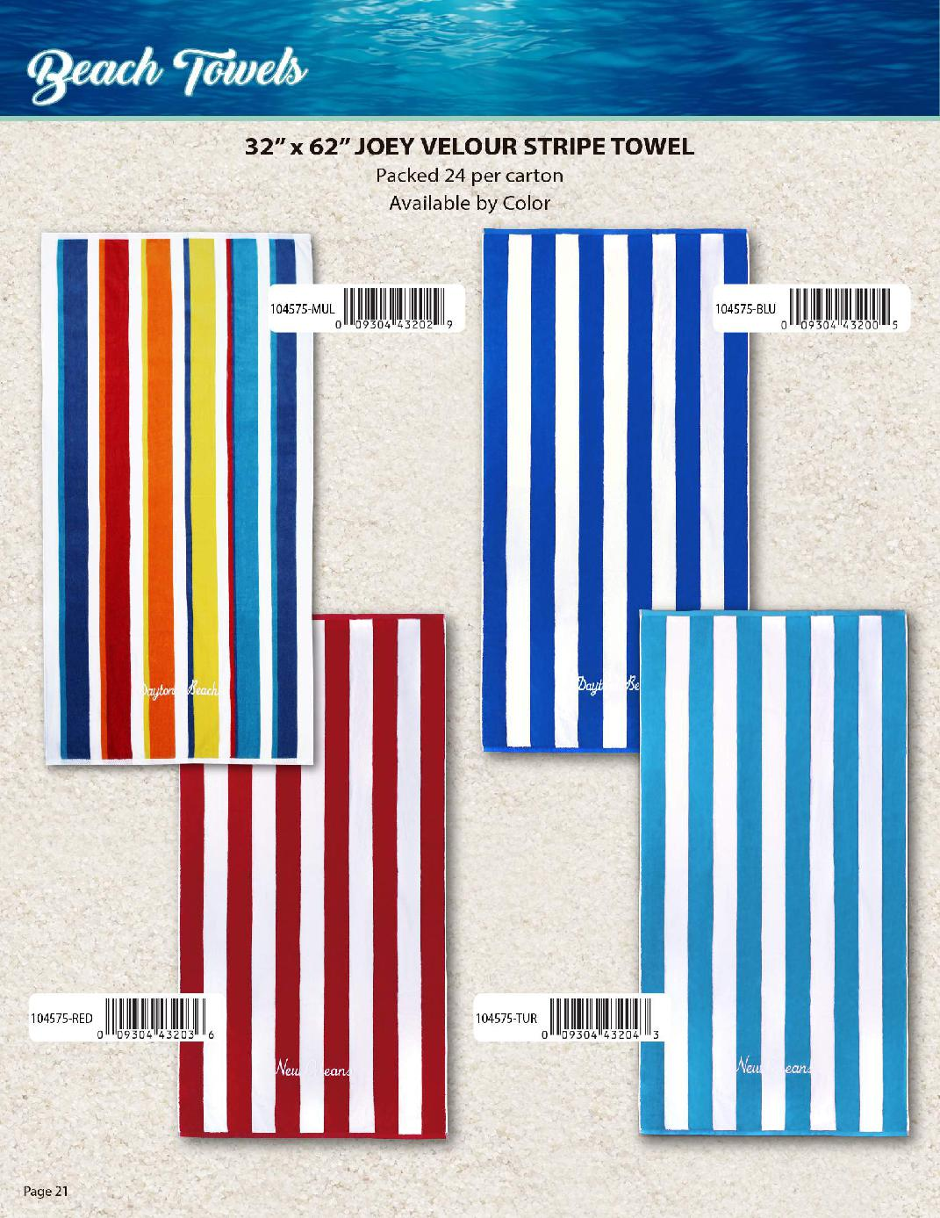

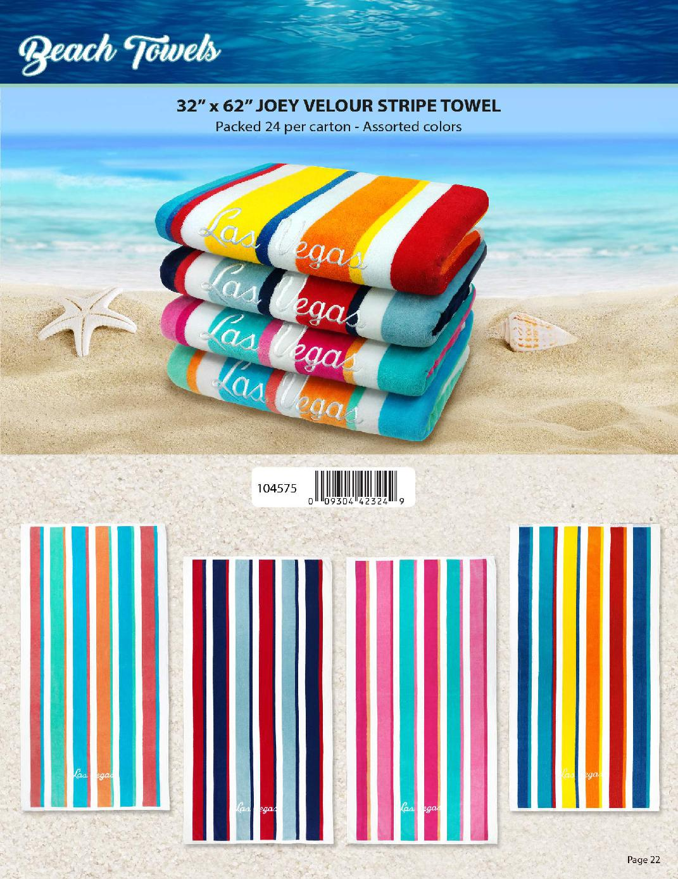
NOTICE
All Products can be ordered BLANK-NO Embellishment
Patrick 303-257-6144
Ron 609-616-5009

NOTICE
All Products can be ordered BLANK-NO Embellishment
Patrick 303-257-6144
Ron 609-616-5009

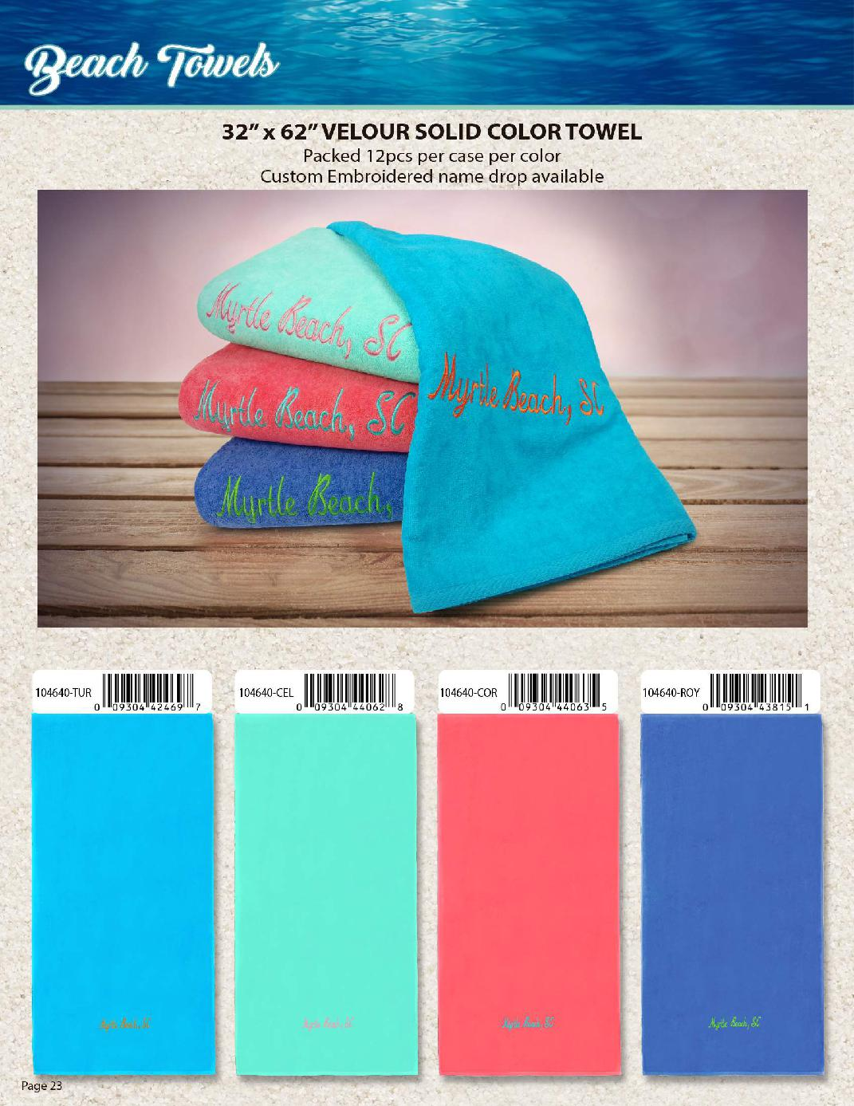

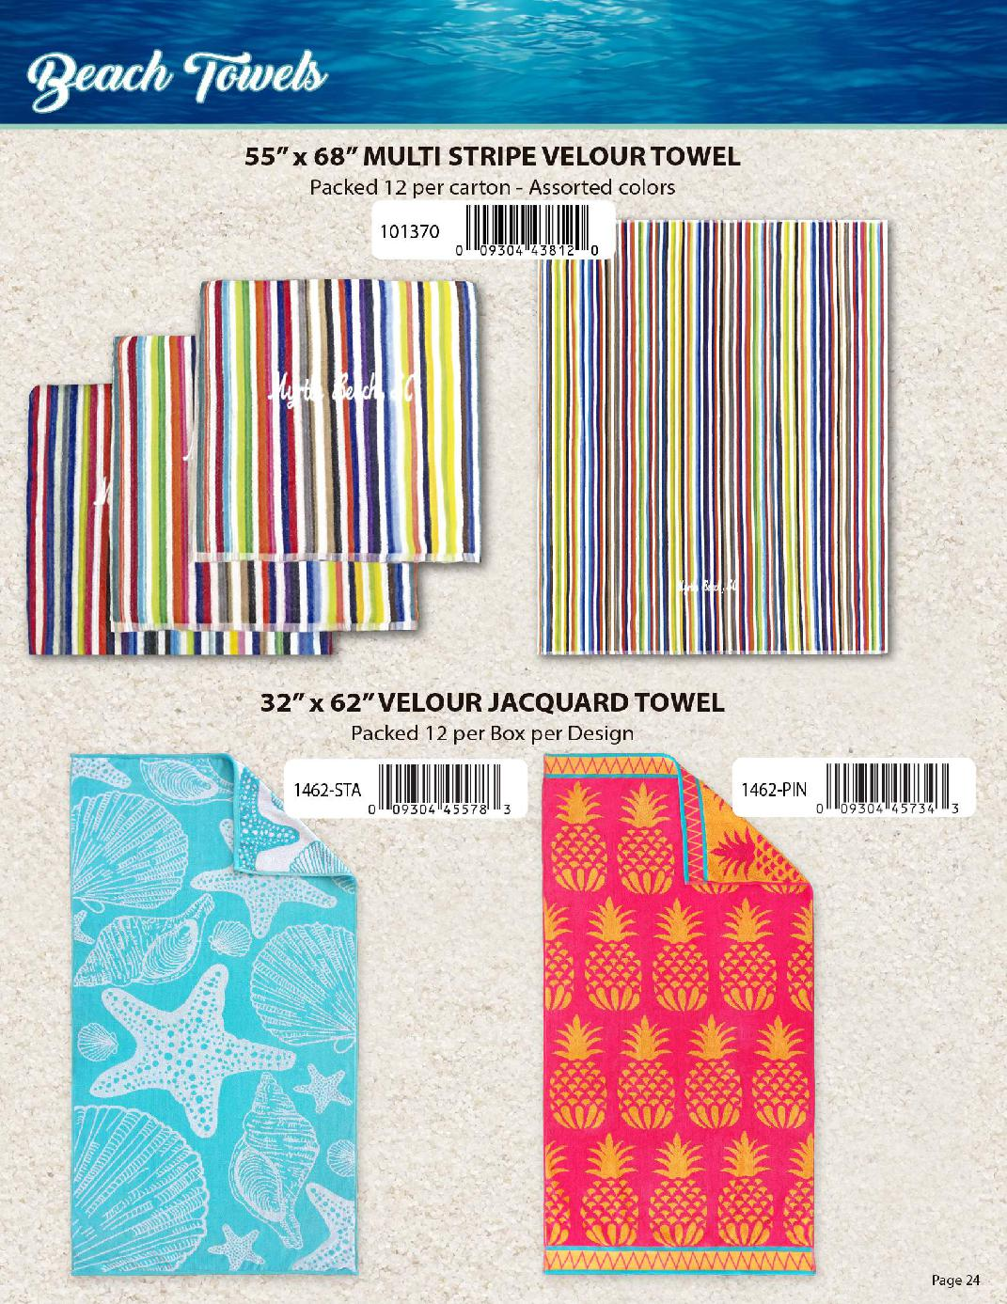

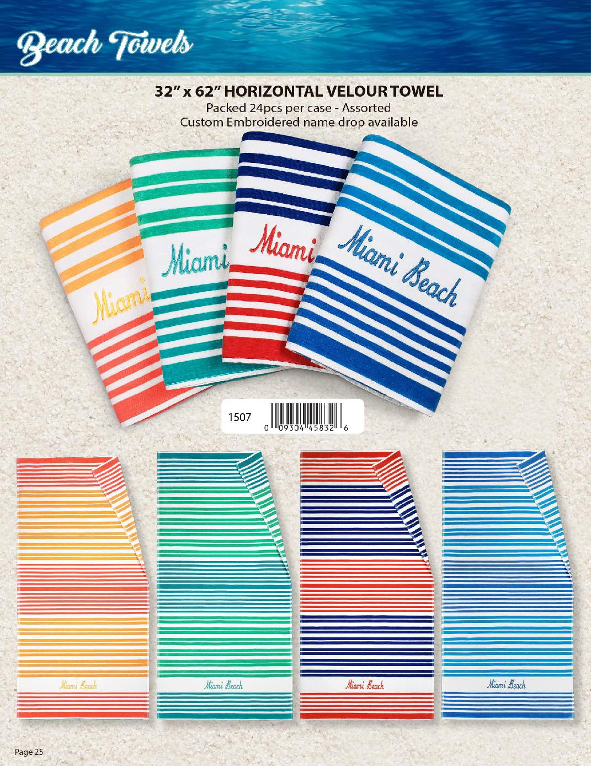
NOTICE
All Products can be ordered BLANK-NO Embellishment
Patrick 303-257-6144
Ron 609-616-5009

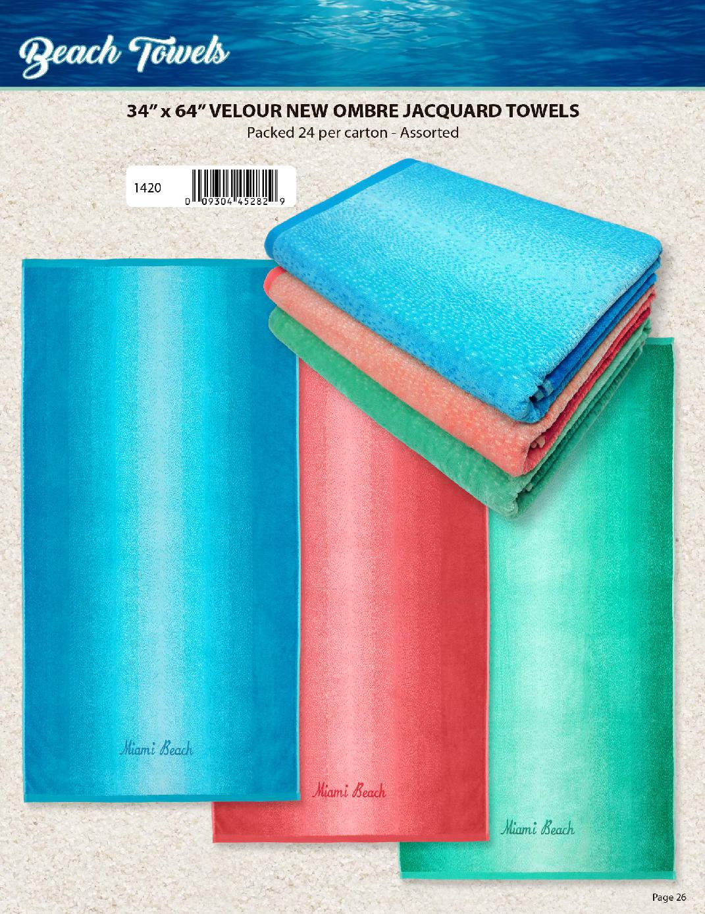

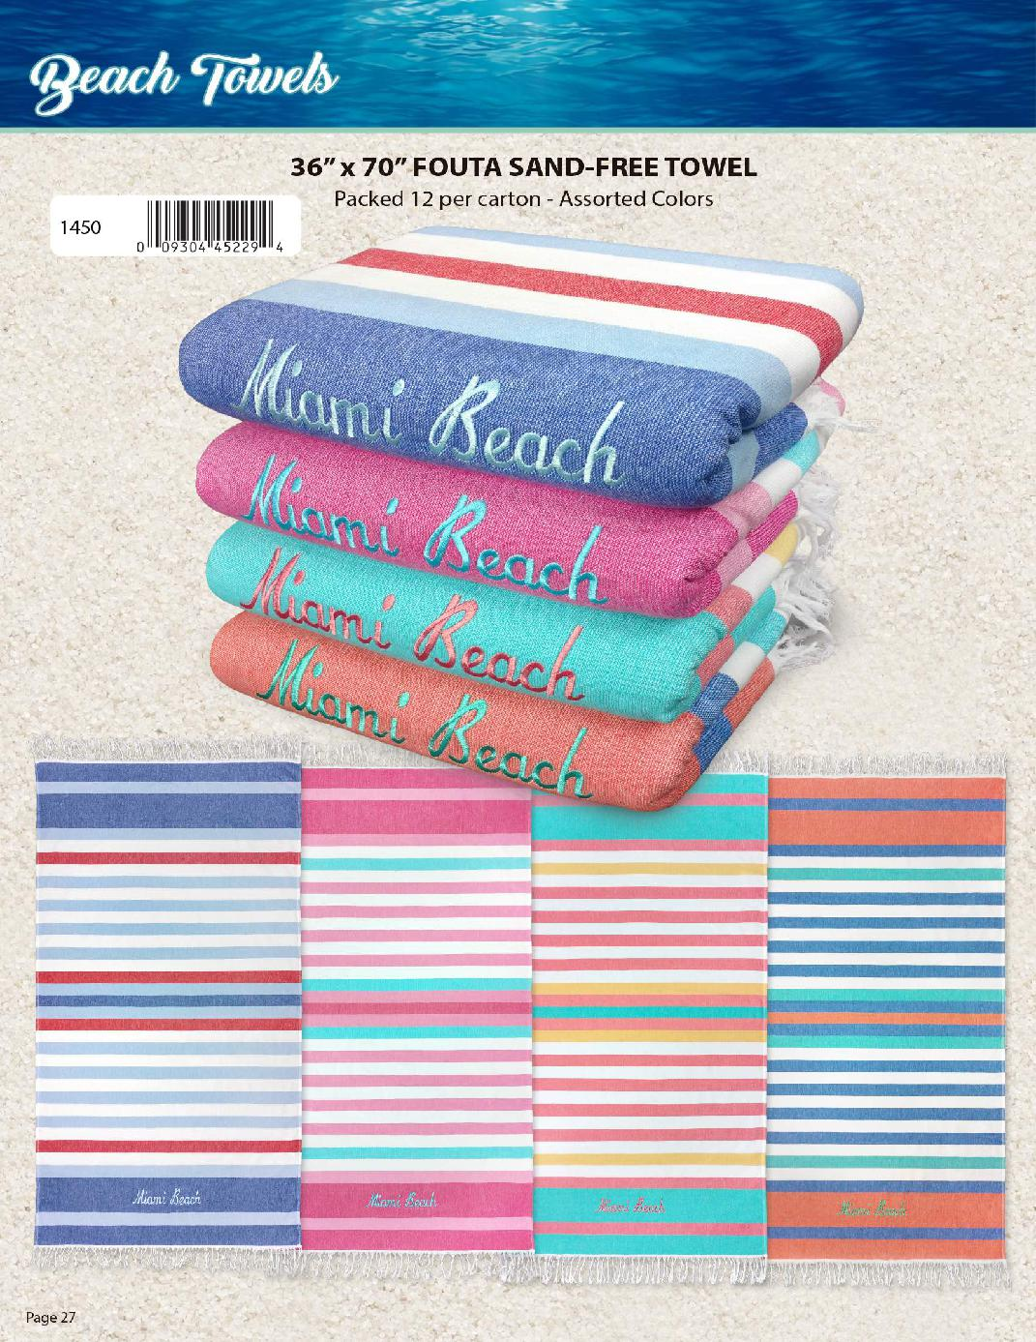
NOTICE
All Products can be ordered BLANK-NO Embellishment
Patrick 303-257-6144
Ron 609-616-5009

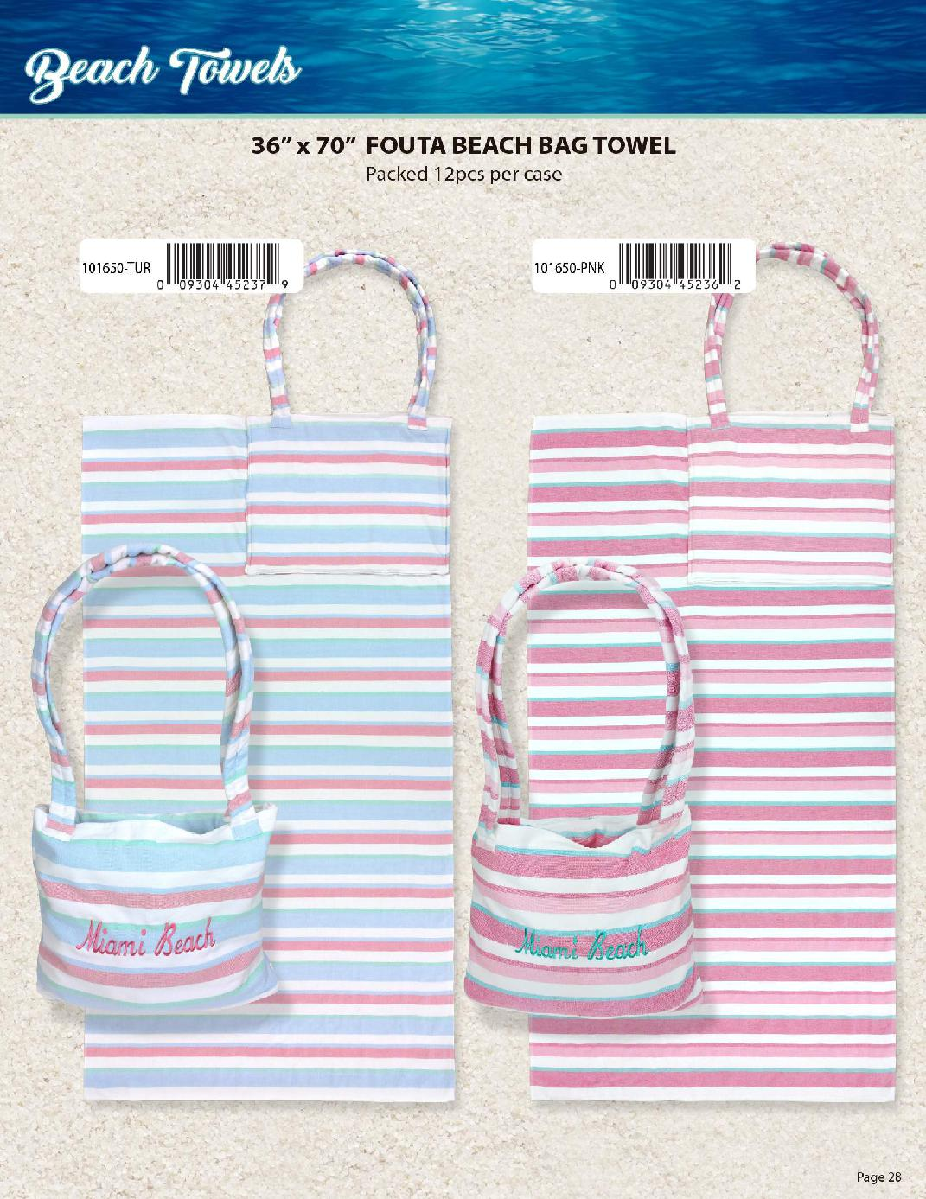

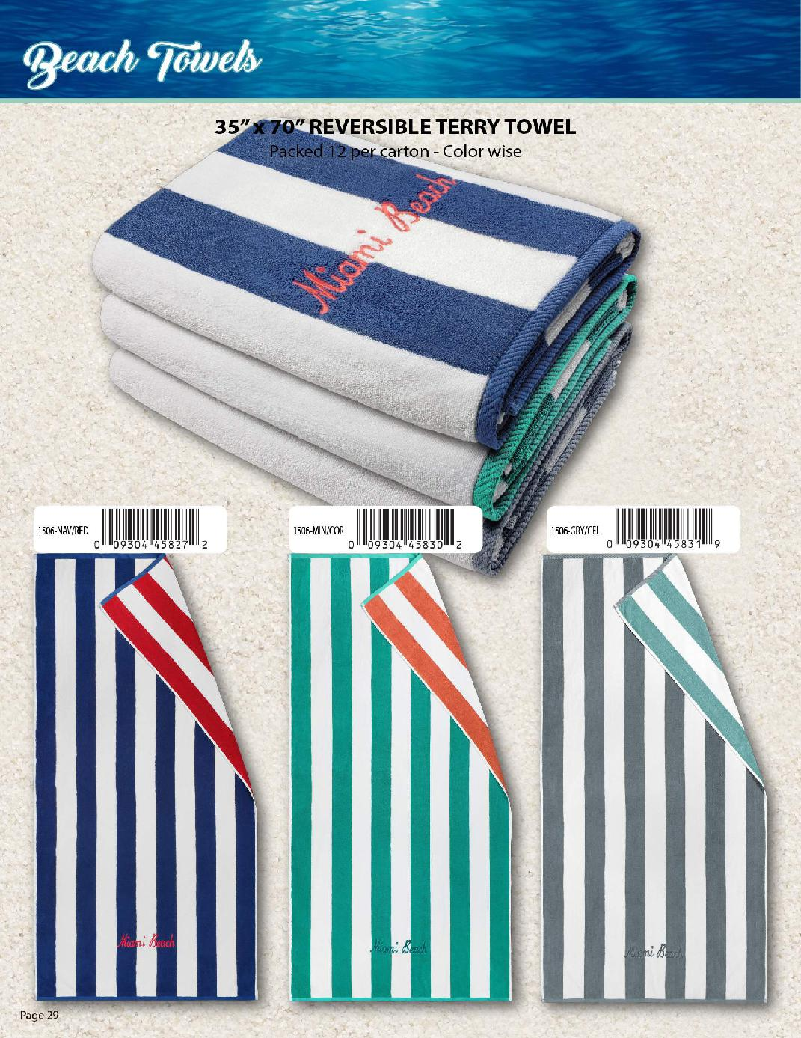
NOTICE
All Products can be ordered BLANK-NO Embellishment
Patrick 303-257-6144
Ron 609-616-5009

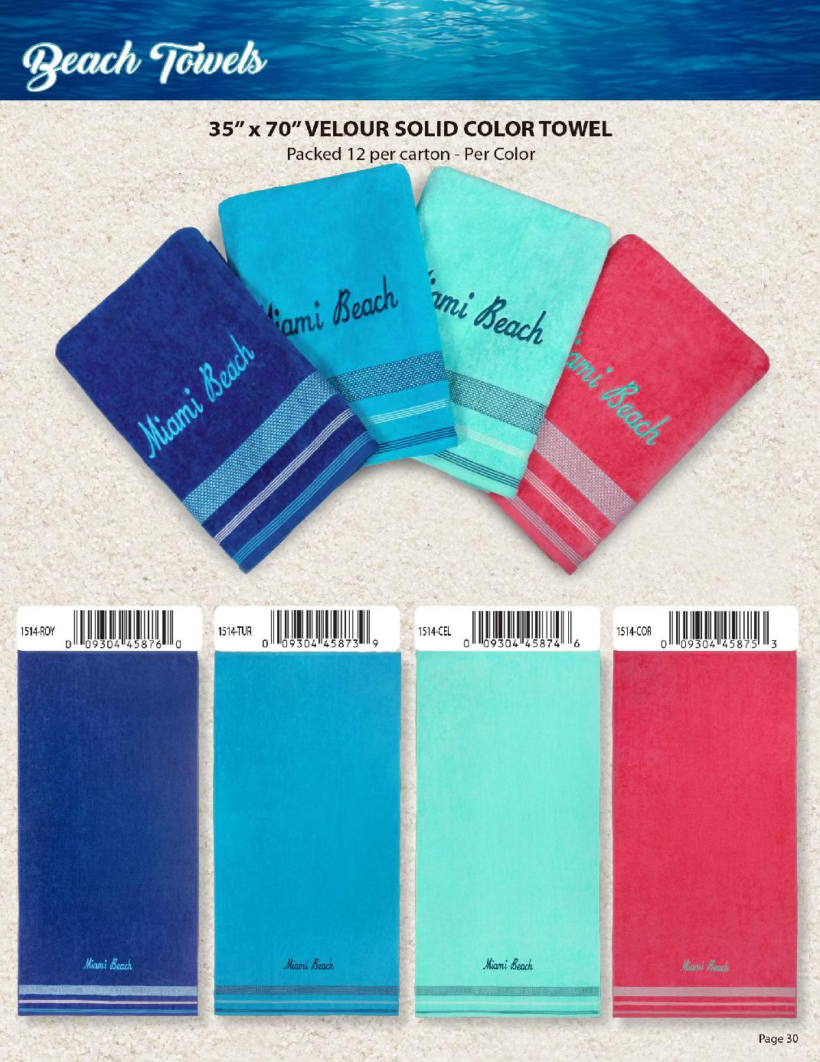
NOTICE
All Products can be ordered BLANK-NO Embellishment
Patrick 303-257-6144
Ron 609-616-5009

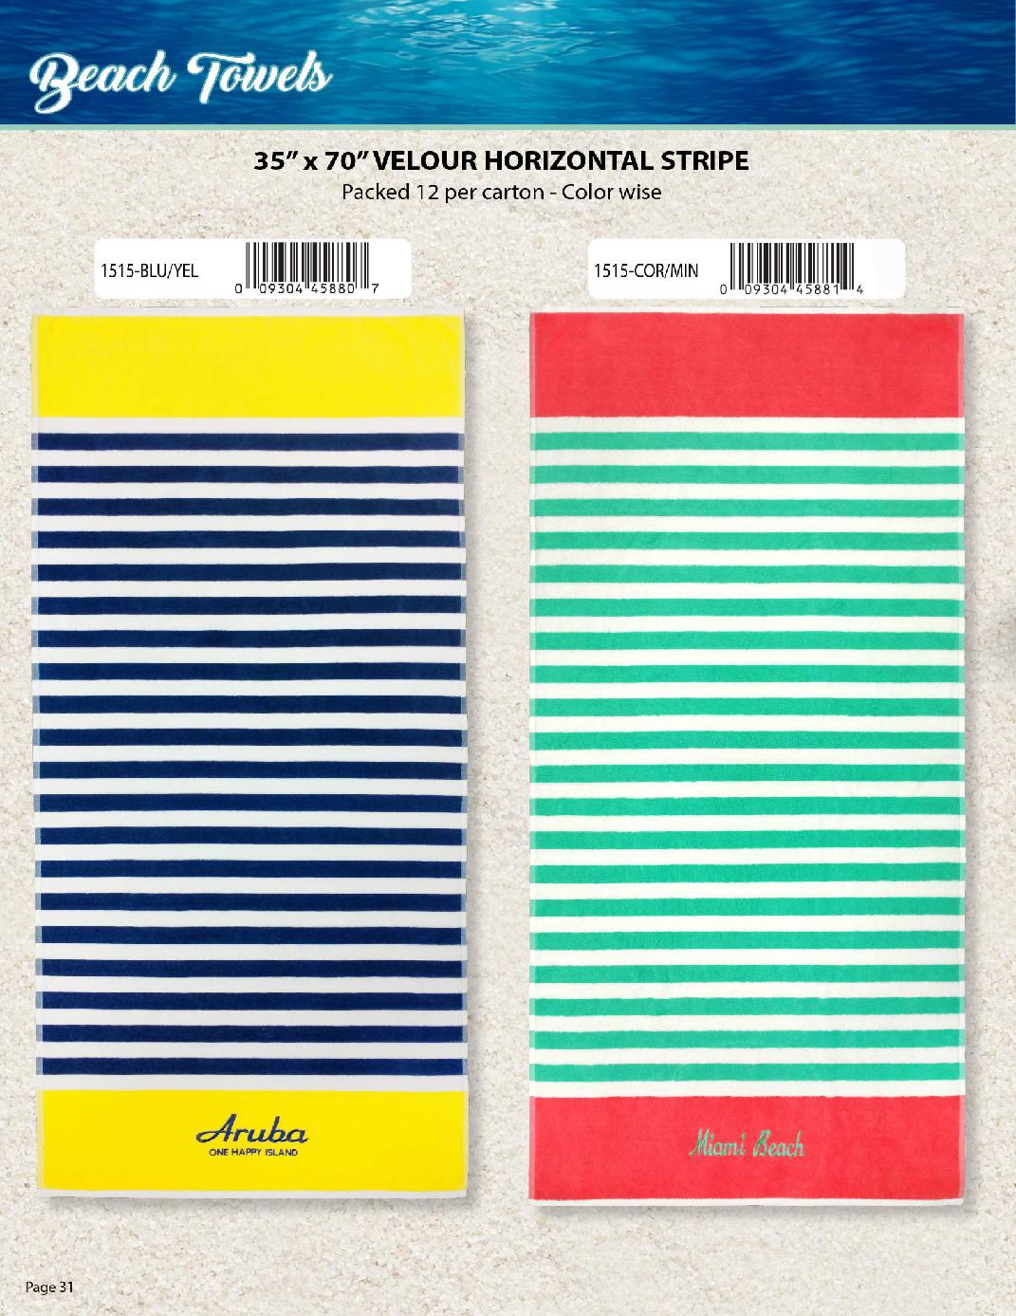

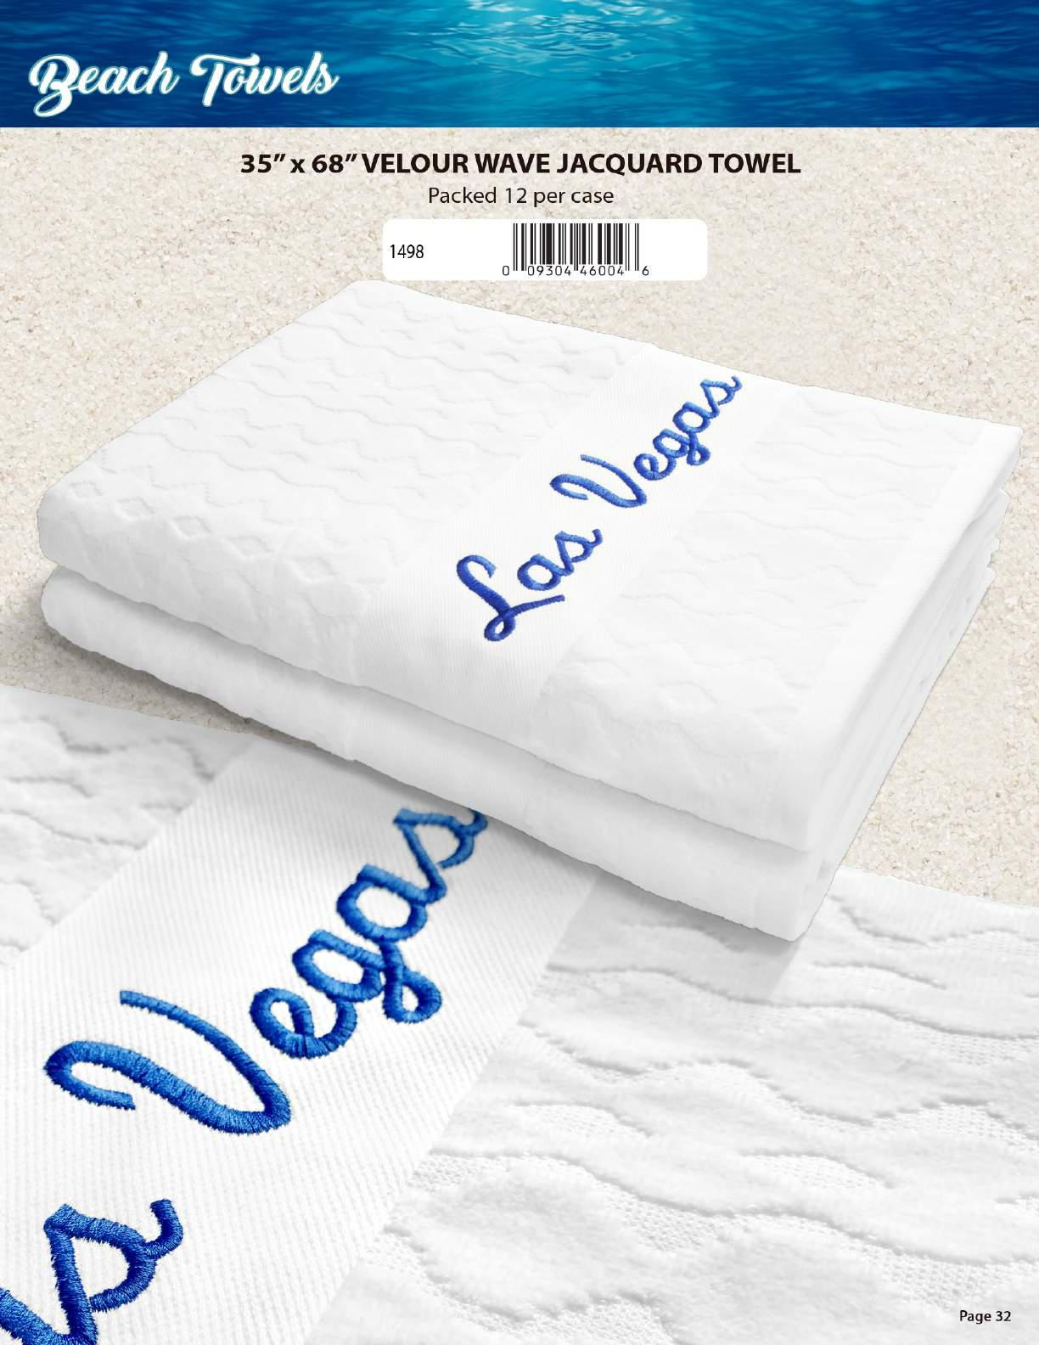
NOTICE
All Products can be ordered BLANK-NO Embellishment
Patrick 303-257-6144
Ron 609-616-5009

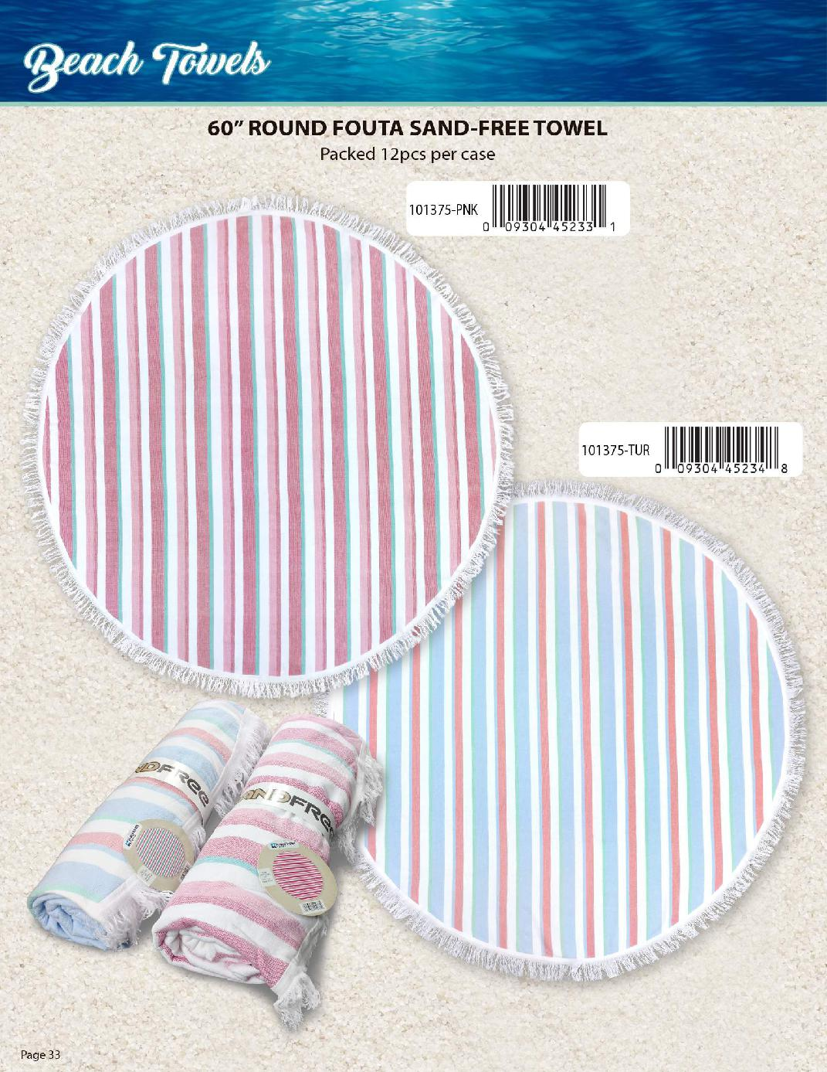
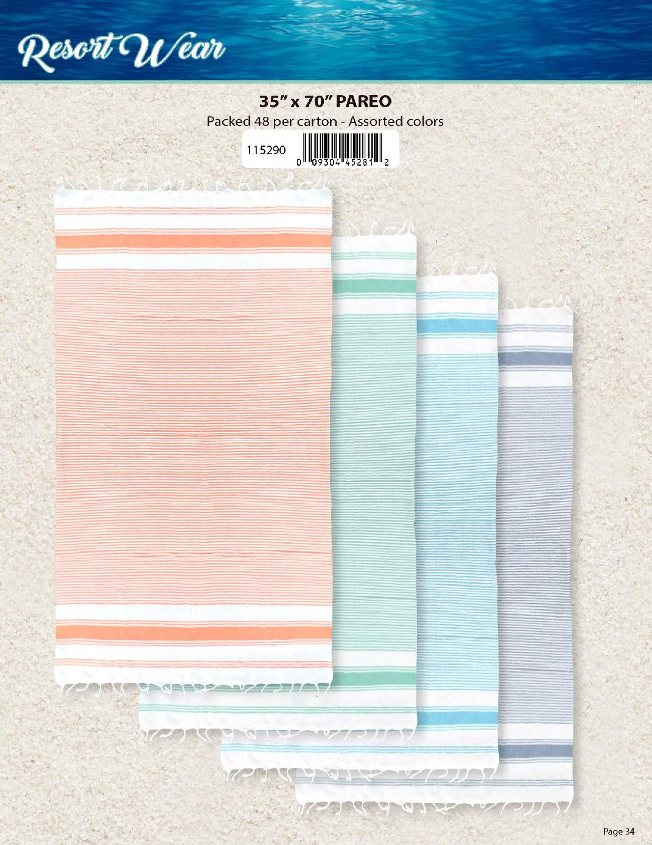
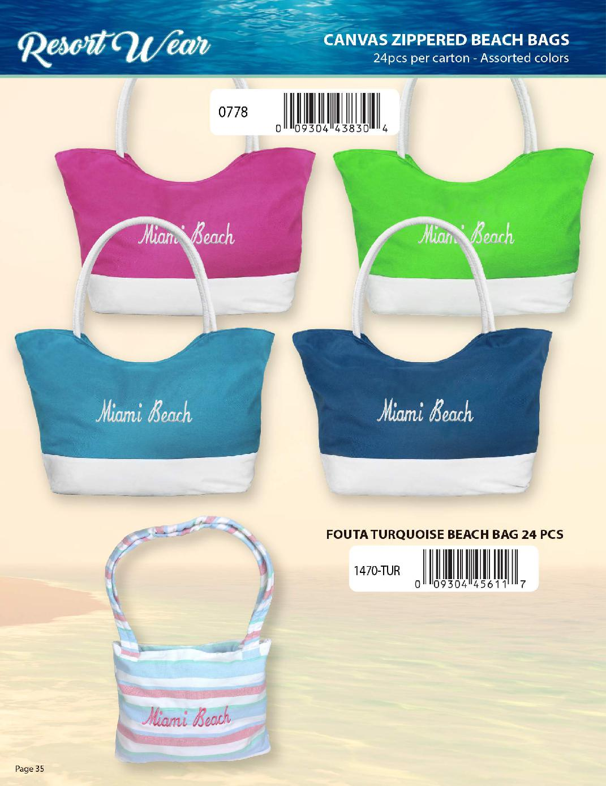
NOTICE: All products can be ordered Blank without Embellishment
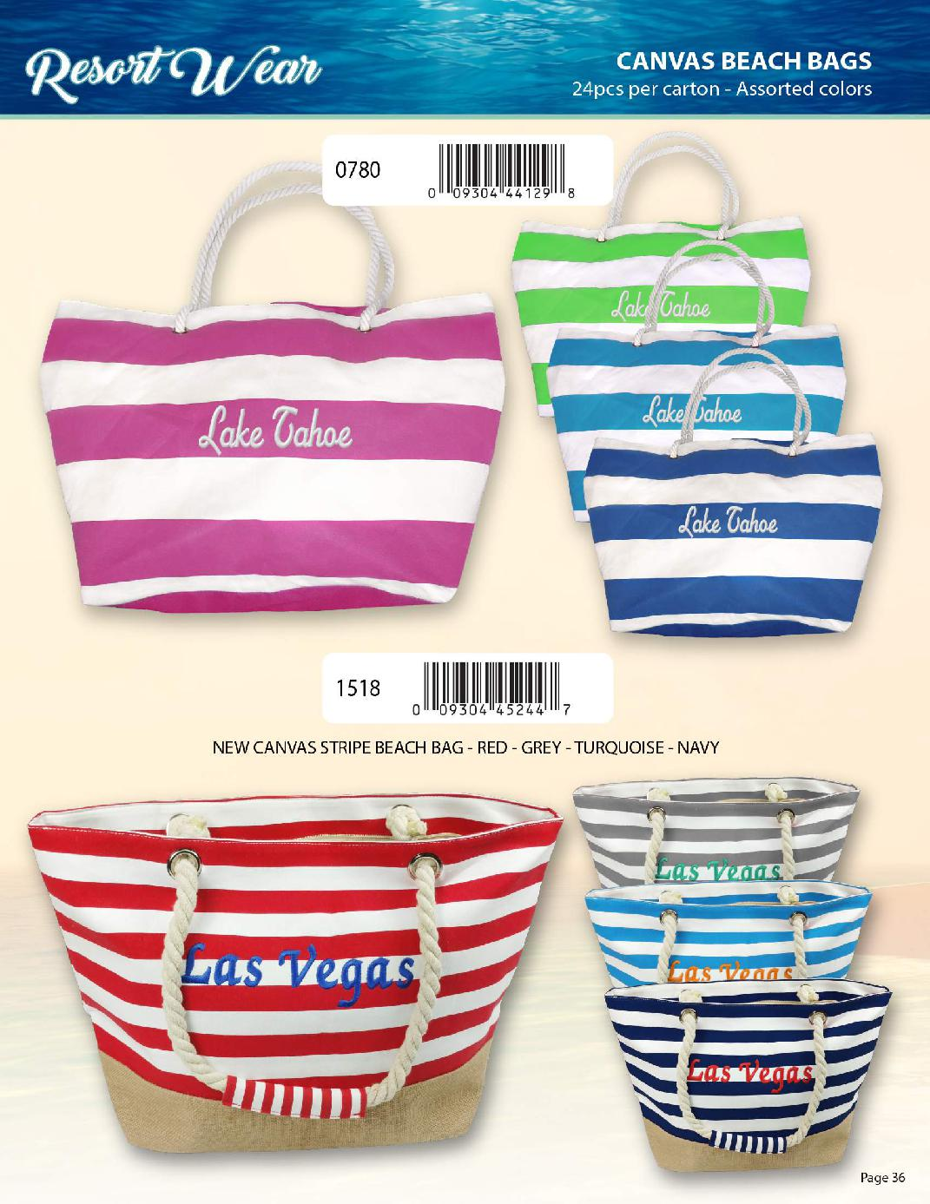
NOTICE-All products can be ordered without Embellishment
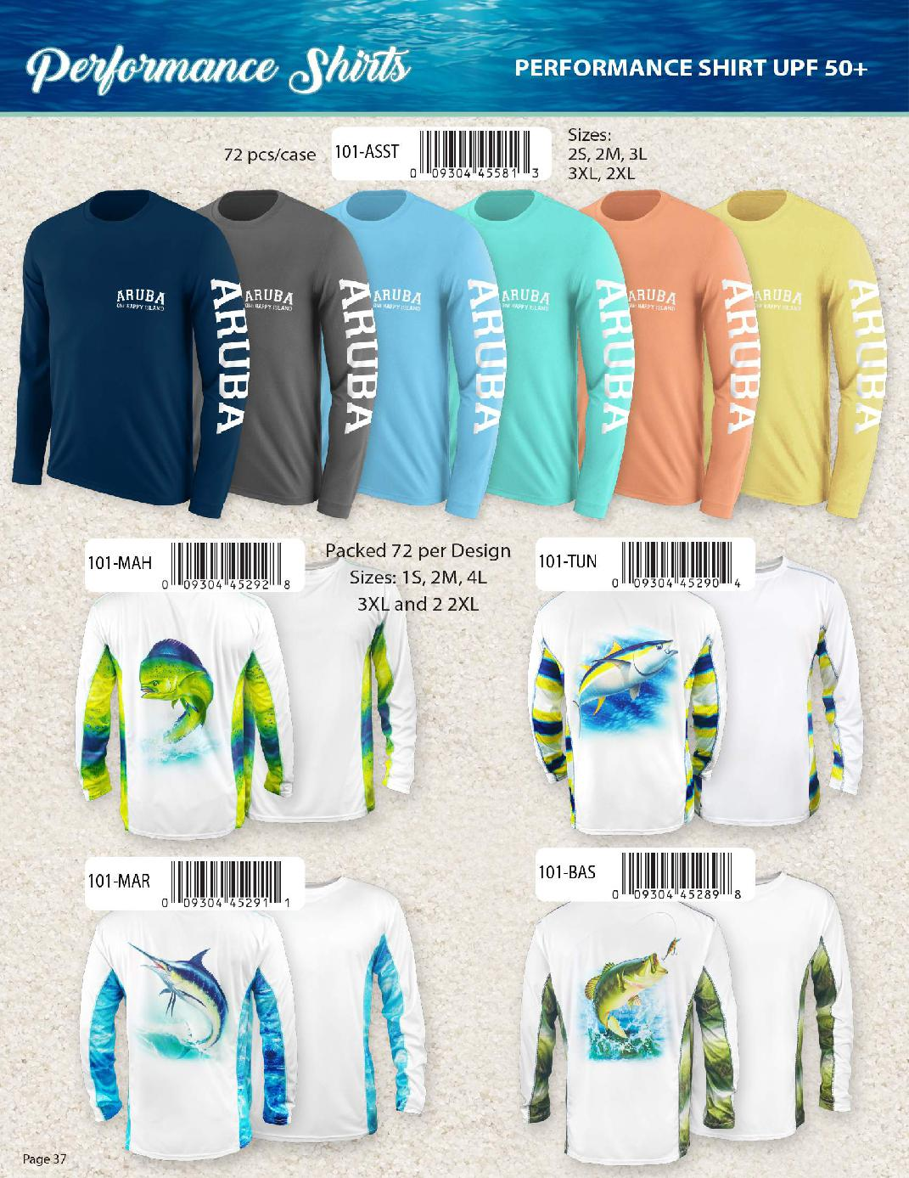
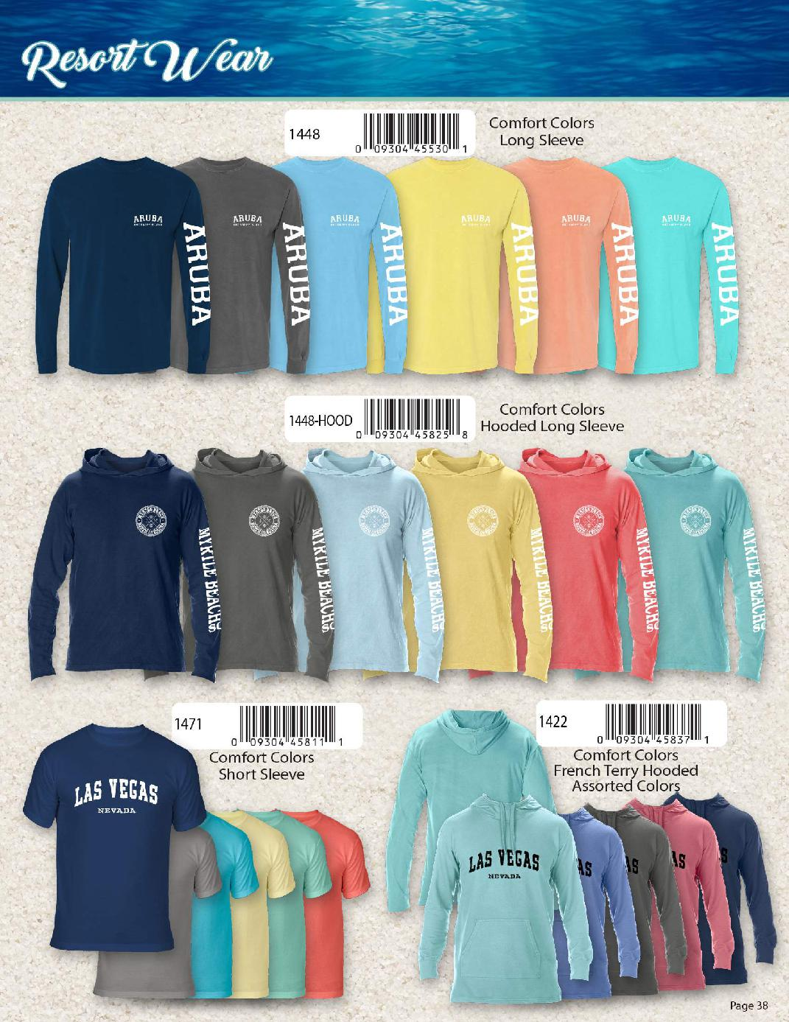
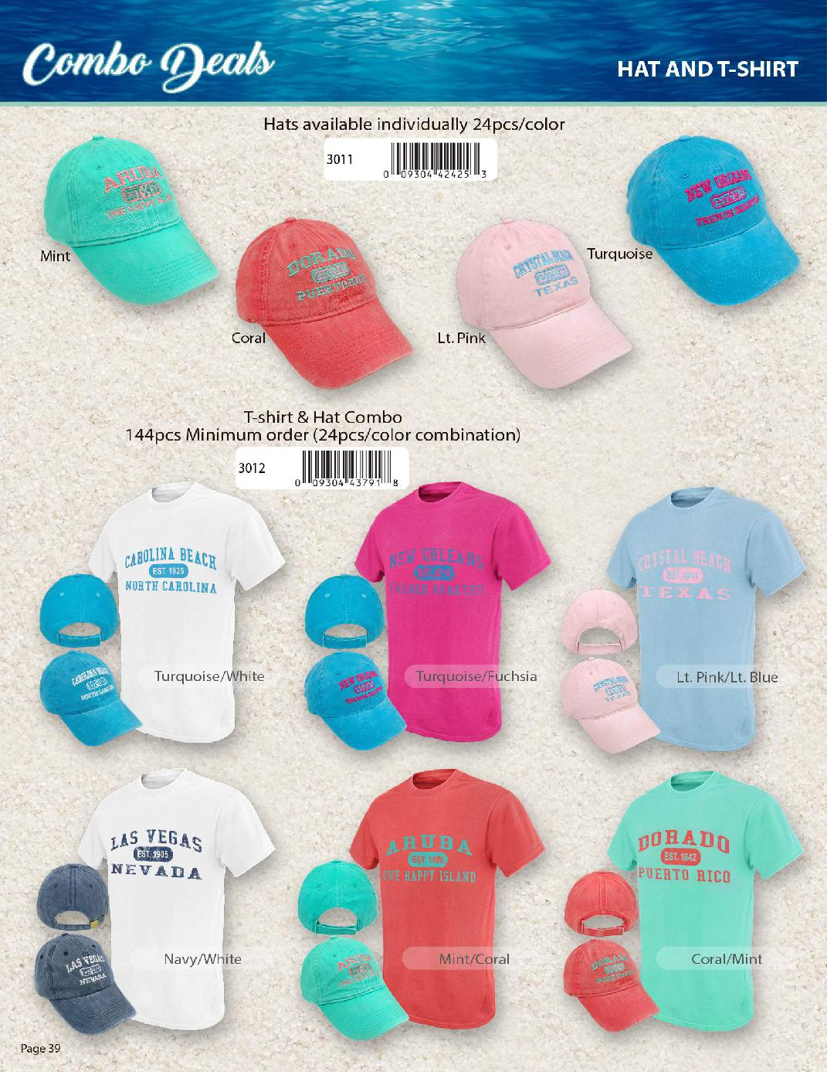
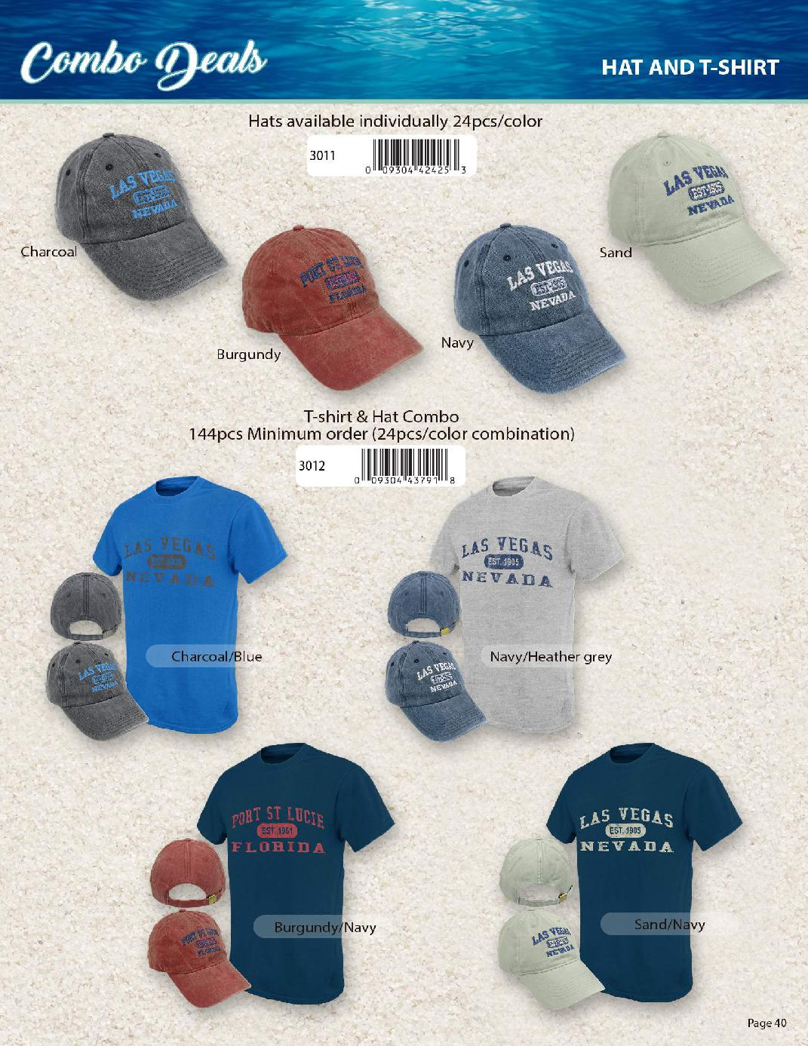

UNITED TEXTILE SUPPLY
303-257-6144 or 609-616-5009
UNITEDTEXTILESUPPLY.COM

